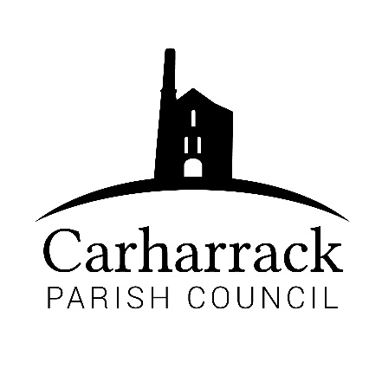 | Carharrack Parish Council
 | Parish Clerk: Joanna Picton
Sparry Farm
Sparry Bottom
Carharrack
TR16 5SH
Tel: 01209 822631

E: carharrackparishcouncil@gmail.com
W: www.carharrackparishcouncil.co.uk
30 July 2026
TO ALL MEMBERS OF THE COUNCIL
I hereby give notice that the Ordinary Council Meeting of Carharrack Parish council will be held on Monday 18th January 2021 via zoom commencing at 6.45pm.

All Members of the Council are hereby summoned to attend for the purpose of considering and resolving upon the business about to be transacted at the meeting as set out hereunder.

Any members of the public wishing to join the meeting please contact the clerk.
Yours faithfully,

Joanna Picton

Joanna Picton, Parish Clerk

AGENDA
- Persons Present/Apologies
To NOTE persons, present and RECEIVE any apologies for absence.
- Chair welcome
- Declarations of Interest from Members / Dispensations
To RECEIVE any Declarations of Interest from Members. To RESOLVE to grant any requests for Dispensation in line with the Councillor Code of Conduct 2012 if appropriate.
- Councillors Report: Update on current issues from C.C. Mark Kaczmarek

- Public Participation
To RECEIVE comments from members of the public. This provides an opportunity for members of the public to comment on items on the agenda as per Standing Orders or otherwise considered at the Chairman’s discretion. Maximum time allowed will total 10 minutes/2 mins per person.
- Defibrillator
To APPROVE payment to Coastline Medic to maintain the Defibrillator.
- Council Meeting: Minutes From 16th December 2020 Zoom meeting
To RESOLVE that the above Minutes of the Meetings of Carharrack Parish Council having been previously circulated, be taken as read, approved and signed. To NOTE any matters arising from the Minutes.
- Allotments/Trees
Allotments: Update from Councillor Aldridge
Trees: to DISCUSS the options for tree distribution options from Councillor Garbett
- Planning Applications:
Application: PA20/11000
PA20/11001
Proposal: PA20/11000 Conversion of existing chapel to form residential dwelling and associated works
PA20/11001 Listed building consent for the conversion of existing chapel to form residential dwelling and associated works
Location: Both: Methodist Church Chapel Terrace Carharrack TR16 5RR
- Park upgrade- Update from Clerk
- Finance (regular) – to approve invoices for payment
- Clerks Salary and expenses/reimbursements
- RFO salary
- Councillors purchase reimbursements for council
- Banking Arrangements- To DISCUSS the current bank accounts
Online Banking- To DISCUSS options for moving forward with the bank account
- Website- To discuss the current website and options for improvements
- Items for agenda:
To NOTE any items for the next Council meeting.
- Public Bodies (Admission to Meetings) Act 1960
To RESOLVE that in view of the confidential nature of the business about to be transacted it is advisable that the press and public be excluded and are instructed to withdraw during the discussion of the following item:
- Of a confidential nature

