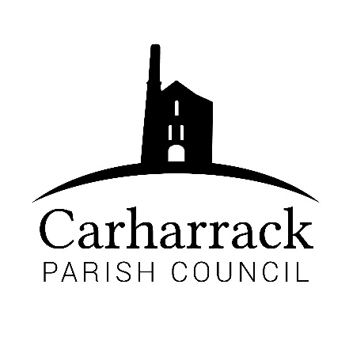 | Carharrack Parish Council
 | Parish Clerk: Joanna Picton
Sparry Farm
Sparry Bottom
Carharrack
TR16 5SH
Tel: 01209 822631

E: carharrackparishcouncil@gmail.com
W: www.carharrackparishcouncil.co.uk
12th July 2021
TO ALL MEMBERS OF THE COUNCIL
I hereby give notice that the Ordinary Council Meeting of Carharrack Parish Council will be held on Monday 19th July 2021 at The Mills Hall, Carharrack at 6pm.

All Members of the Council are hereby summoned to attend for the purpose of considering and resolving upon the business about to be transacted at the meeting as set out hereunder.

If possible, please contact the clerk to express your interest in attendance to help comply with the current covid restrictions. Please use hand sanitiser provided and wear a face mask.
Yours faithfully,
Joanna Picton
Joanna Picton, Parish Clerk

AGENDA
1. Persons Present/Apologies - To NOTE persons present and RECEIVE any apologies for absence.
2. Chair welcome
3. Declarations of Interest from Members/Dispensations
To RECEIVE any Declarations of Interest from Members. To RESOLVE to grant any requests for Dispensation in line with the Councillor Code of Conduct 2012 if appropriate.
4. Public Participation
To RECEIVE comments from members of the public. This provides an opportunity for members of the public to comment on items on the agenda as per Standing Orders or otherwise considered at the Chairman’s discretion. Maximum time allowed will total 10 minutes/2 mins per person.
5. Cornwall Councillors Report Update on current issues from C.C. Connor Donnithorne
6. Council Meeting Minutes for the meeting held on 21st June 2021
To RESOLVE that the above Minutes of the Meetings of Carharrack Parish Council having been previously circulated, be taken as read, approved, and signed. To NOTE any matters arising from the Minutes.

7. Traffic Update - To DISCUSS the updates from the previous meeting
8. Allotments – Update from Cllr Aldridge
- Open Day – Final Arrangements
- Proposal for changes to annual plot fees to commence 1st November 2022:
All plot fees for exisitng plot holders to increase by £2 each. There is to be an additional annual charge for a large polytunnel of £3 and for a small polytunnel of £2.
From November 2022 any new plot holders will pay a fee based on the dimensions of the plot at a charge of 60p per square meter.
9. Defibrillator
To APPROVE the purchase of a second defibrillator to be sited at St Piran's Church
- St. Day and Carharrack Climate action group - Update from Cllr Garbett
11. Carharrack Playing Field – Consider responses following a visit to the playing field by Year 4 pupils from St Day and Carharrack Community School.
12. Police Liaison Meeting- Report from Cllr Chown
- Environment
To DISCUSS and APPROVE a “landmark tree”
Footpaths
14. Planning Applications:
- Ref No PA21/05051
Proposed new garage and store at Bal Zan, North Hill, Carharrack, TR16 5RG
- Ref No PA21/05218
Development of three dwellings with non compliance with condition 2 in relation to decision notice PA20/00919 dated 11.09.2020 – Land north of 6 Manor Road, Carharrack, TR16 5SD
15. Finance - to APPROVE the Financial Statement and the following invoices for payment:
- Clerks Salary, Expenses and Reimbursements – Website fees, Laminator pouches
- RFO Salary
- HMRC Payment
- Allotment Expenses
Annual Audit for year ending 31st March 2021 – To DISCUSS and APPROVE

- Agenda Items - To NOTE any items for the next Parish Council meeting schedule for:
Monday 20th September 2021

