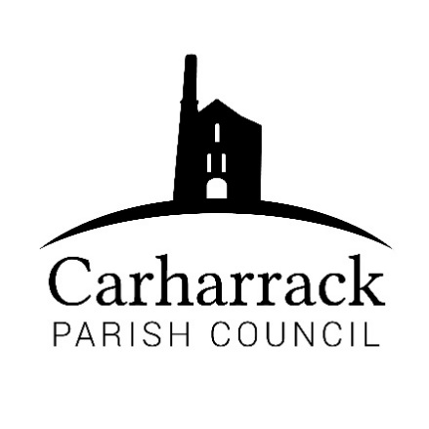 | Carharrack Parish Council
 | Parish Clerk: Joanna Picton
Sparry Farm
Sparry Bottom
Carharrack
TR16 5SH
Tel: 01209 822631

E: carharrackparishcouncil@gmail.com
W: www.carharrackparishcouncil.co.uk
Ordinary Council Meeting Minutes- 14th December 2020
6.45pm start Held Via Zoom

- Persons Present/Apologies
Present: Cllr Holland, Cllr Aldridge, Cllr Chown, Cllr Martin, Cllr Garbett, Cllr Constable, Cllr Pearson, T. Hill, Cornwall Councillor Mark Kaczmarek
4 members of the public
Invited speakers from The Geothermal Distillery Company
- Chair welcome: Chair opens the meeting with a greeting to the council and all attending
- Declarations of Interest from Members / Dispensations: None
- Councillors Report: Written report had been circulated to the Parish Councillors prior to the meeting. CC Kaczmarek emphasised the on-going need to keep to the guidelines with regard to the Covid-19 pandemic. Increases expected in council tax to help social care and the funding for Cornwall from the EU will reduce from 70 million to 1.5 million.
- Public Participation
None
- Geothermal Distillery
Presentation given to the meeting by Matthew Clifford from The Cornwall Geothermal Distillery Company regarding the application for a rum maturation plant and visitor centre at United Downs.
Parish Councillors, and on this occasion members of the public, were invited to asked questions. Full contact details for further questions is available in the latest edition of the Parish magazine and via the clerk.
Copy of the presentation will be forward to the clerk for distribution to the Parish Councillors.
- Council Meeting: Minutes of the meeting held on 23rd November 2020 via Zoom were agreed as a correct record and signed by the Chair.
There were no matters arising
- Plot 48 Allotment site-
Cllr Aldridge reported to the Parish Council concerns about plot 48. Payment from the allotment holder has just been received. Site inspection to be carried out and issues of H&S will be advised to the plot holder.
- Planning Applications:
Application: PA20/04337
Proposal: Change of use of part of field for access from highway to Mount Pleasant
Location: Mount Pleasant, Woodbine Hill, Carnmarth, Carharrack Applicant: Mr & Mrs Zeat-Kane
Cllr Garbett advised that the access/entrance drive is not on the bend and there was no reason to object. Cllr Martin advised that this application has been considered at a previous meeting with the comment to be returned to planning that guidance should be sought from highways regarding visability onto the lane for vehicluar access, but otherwise no objections.
- Park upgrade- Discussion about the plans that have been previously circulated. Clerk to obtain feedback from the public when possible.
- Finance – £652.73 outgoing
Cllr Chown Proposer, Cllr Aldridge seconded
- Clerks Salary and expenses/reimbursements
- RFO salary
- Banking Arrangements- Discussion took place about the current banking arrangements which are proving problematic for a number of reasons. Ethical banking would be preferable or use of a local bank in Reduth. General agreement that the Parish Council should change it bank and the Clerk and RFO to research two possible options in readiness for the next meeting.
- Park Stenak Amenity area- Area has been cleared and is looking much better. Discussion ensues about the questionnaire and moving forward with the space. Family use, wellbeing and quiet space. We need to draw up a list of volunteers and have a meeting next spring on-site. Footpath is the responsibility of the residents. A follow-up letter will be sent to all residents advising that when safe to do so we will arrange a site meeting.
- LMP Tender – One tender has been received from a contractor known to the Parish Council. Aspects of the tender reviewed. Allotment entrance to be maintained by an allotment holder. Park Stenak amenity area will require more than one cut – possibly 3 during the course of the year. Sparry Lane hedge has been cut by Cornwall Council. Cllr Garbett receommended the contractor. Proposer: Cllr Aldridge Seconder: Cllr Constable. No objections.
- Items for agenda: Trees – Cllr Garbett, Entrance to the Allotments – Cllr Aldridge Full list of dates of 2021 meetings to be circulated. The Playing Field, Up-date on Park Stenak, Trees to be planted; Cllr Garbett, Extension to allotment gate, Bank accounts, Dates for meetings for 2021.
Chair closes the meeting at 20.10

