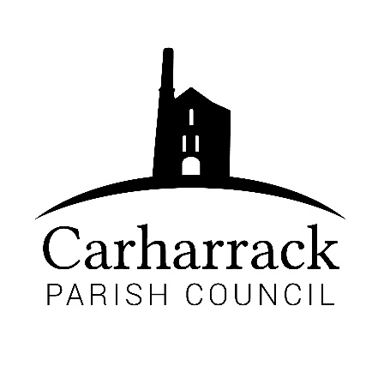 | Carharrack Parish Council
 | Parish Clerk: Joanna Picton
E: carharrackparishcouncil@gmail.com
W: www.carharrackparishcouncil.co.uk

2nd December 2021
TO ALL MEMBERS OF THE COUNCIL
I hereby give notice that the Ordinary Council Meeting of Carharrack Parish Council will be held on Monday 13th December 2021 at The Mills Hall, Carharrack at 7pm.

All Members of the Council are hereby summoned to attend for the purpose of considering and resolving upon the business about to be transacted at the meeting as set out hereunder.

If possible, please contact the clerk to express your interest in attendance to help comply with the current covid restrictions. Please use hand sanitiser provided and wear a face mask in accordance with Government regulation.

Yours faithfully,
Joanna Picton
Joanna Picton, Parish Clerk
AGENDA

- Persons Present/Apologies - To NOTE persons present and RECEIVE any apologies for absence.

- Chair Welcome

- Declarations of Interest from Members/Dispensations
To RECEIVE any Declarations of Interest from Members. To RESOLVE to grant any requests for Dispensation in line with the New Councillor Code of Conduct 2021 if appropriate.

- Public Participation
To RECEIVE comments from members of the public. This provides an opportunity for members of the public to comment on items on the agenda as per Standing Orders or otherwise considered at the Chairman’s discretion. Maximum time allowed will total 10 minutes/2 mins per person.

- Cornwall Councillors Report Update on current issues from C.C. Connor Donnithorne

- Parish Council Meeting Minutes for the meetings held on 26th October 2021 (full parish council meeting) and 22nd November 2021 (planning & finance meeting)

To RESOLVE that the above Minutes of the Meetings of Carharrack Parish Council having been previously circulated, be taken as read, approved, and signed. To NOTE any matters arising from the Minutes.

- The Pound
(a) To discuss and approve a new information sign for The Pound
(b) To advise and approve changes to land registration for The Pound

- Park Stenak- Councillors to approve a letter to be sent regarding the transfer of ownership of the amenity land to the Parish Council.

- Finance:
- To APPROVE payment to Southwest Water for payment of latest invoice for the allotment site. To APPROVE a direct debit to be set up for future payments.
(b) To APPROVE invoice payment to CALC for training
(c) To APPROVE salary payments and reimbursement for website for clerk
(d) To APPROVE payment for contract work at the allotments and Sparry Lane hedge overgrowth
(e) To APPROVE an accessible bench with a shelter for the park and APPROVE amount to be contributed towards the bench from the Parish council
(f) To CONFIRM and APPROVE a donation to the Mills Trust
(g) To APPROVE a quote for the removal of the ash tree on Shute Hill and APPROVE payment for the work once completed

- Planning Applications:

PA21/02065/PREAPP | Pre-application advice to move warm up area to position shown on proposed site plan, parking where shown and modified stable block. For use with the existing business. | Primrose Villa Chenhale Carharrack Redruth Cornwall TR16 5RB

- Plastic Free Community – Support and APPROVE MOTION to register and achieve accreditation for Carharrack as a Plastic Free Community

- Agenda Items - To NOTE any items for the next Parish Council Meeting

