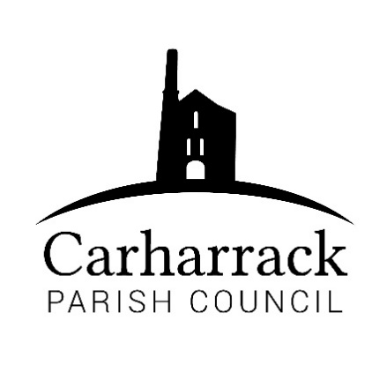 | Carharrack Parish Council
 | Parish Clerk: Joanna Picton
Sparry Farm
Sparry Bottom
Carharrack
TR16 5SH
Tel: 01209 822631

E: clerk@Carharrackparishcouncil.co.uk
W: www.carharrackparishcouncil.co.uk
Parish Council Meeting Minutes – 15th May 2023 OM15/05
7pm at The Mills Hall, Carharrack

- Election of chair for Parish year 2023-2024- Cllr Aldridge nominated Cllr Holland, all voted in favour.

- Chairpersons’ acceptance of office- Chair signs and accepts the offer.

- Election of Vice Chair for Parish year 2023-2024- Cllr Constable is nominated as vice chair, all voted in favour.

- Person’s present/apologies- Apologies Cllr Payne- joined via video link to vote for a chair and vice chair, CC Connor Donnithorne. Present- Cllr Holland, Cllr Aldridge, Cllr Constable, Cllr Harry, Cllr Garbett. Clerk Mrs Picton.

- Declaration of interests- Cllr Aldridge, the Mills Hall.

- Updates from CC Donnithorne- One of the issues is potholes, but one has been reported by the parish council this week. Community Chest investments, asking for people to come forward for funding money, for their club or group in the community.

- Appointment to members of outside bodies- MVRG- Cllr Aldridge and Cllr Holland, CPIR-links to be sent out in advance to offer a seat to a councillor, Police liaison meetings- Cllr Garbett.

- Confirm approved standing orders, financial regulations, and other policies- All in Favour, all voted in favour of the policies.

- Review inventory of land and assets- see list Proposed by Cllr Aldridge and seconded by Cllr constable, all in favour.

- Carharrack Allotment Site Managed by Carharrack PC Land owned by Cornwall Council
- Sparry Lane, Carharrack
- CL137035 – The Pound Freehold – Carharrack PC Conservation Area, no public access
- The Shute, Shute Hill, Carharrack
Freehold – gifted to PC
- Bus Shelter, Fore Street, Cleaned and Maintained by CPC Been in situ for 16+ years
- Bus Shelter, Albion Row, Cleaned and Maintained by CPC Been in situ for 16+ years
- New noticeboards Purchased in 2022 and 2023
- The Allotments, Sparry Lane-Bench
- St Pirans Church, Church Row, Carharrack
- 2 x benches Old Feed Store, Carharrack
The Allotments, Carharrack
- “Tommy” sign – The Park Purchased Spring 2021
- Defibrillator – sited at The Mills Hall, Albion Road, Carharrack
- The Allotment Site, Sparry Lane, Carharrack:
2 x lawn mowers
2 x wheelbarrows
2 x sheds
Water Container (350gallon)
2 x picnic tables
2 x strimmer Purchased May 2022
- Triangle of land maintained by the parish council outside the gate.
- New sign at the Pound field, fencing and gate.

The allotments- The toilet housed in separate concrete building is maintained by the Parish Council, it was built by Ocean Housing when they built Poldory housing and required access to the allotment site. In payment they built the toilet.

- Review insurance cover-to check adequacy and consider the renewal- Proposed by Cllr Aldridge and seconded by Cllr constable. All in favour.

- Review council’s membership of outside bodies- CALC and The Allotments society. Proposed by Cllr Harry, seconded by Cllr Constable. All in favour.

- To ACCEPT the internal auditors report and recommendations- Proposed by Cllr Aldridge, seconded by Cllr constable, all in favour.

- Finances-
- Total: £1049.71
Proposer- Cllr Harry seconded -Cllr Aldridge
- Grant application form- Climate action group- £100 asked for their upcoming event. Cllrs discuss the application. Proposed by- Cllr Aldridge and seconded by Cllr Constable. All in favour.

- Nominating a voting member for the CPIR panel network- Cllr Holland introduces the role and explains to council the method of voting. Cllr Holland to continue. Proposed by Cllr Aldridge and seconded by Cllr constable, all in favour.

- Magazine quotes- Councillors discuss the magazine and local magazines to compare. New quote proposed by Control Print £667.00. All in favour for the new quote.

- Planning- : PA23/03282, Cllrs discuss the application. No objections from Carharrack parish council.

- Agenda items- Bus shelter. Defib training.

- Councillors’ roles- Cllrs discuss meetings and who can attend.

Chair ends the meeting at 20:03

