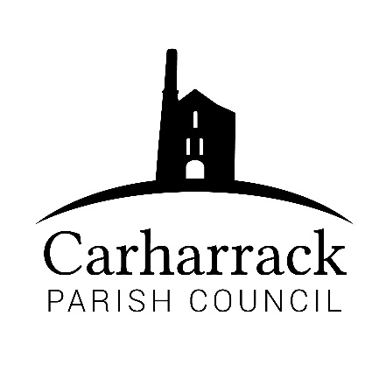 | Carharrack Parish Council
 | Parish Clerk: Joanna Picton
Sparry Farm
Sparry Bottom
Carharrack
TR16 5SH
Tel: 01209 822631

E: carharrackparishcouncil@gmail.com
W: www.carharrackparishcouncil.co.uk
29 July 2026
TO ALL MEMBERS OF THE COUNCIL
I hereby give notice that the Ordinary Council Meeting of Carharrack Parish council will be held on Monday 23rd November 2020 via zoom commencing at 6.45pm.

All Members of the Council are hereby summoned to attend for the purpose of considering and resolving upon the business about to be transacted at the meeting as set out hereunder.

Any members of the public wishing to join the meeting please contact the clerk.
Yours faithfully,

Joanna Picton

Joanna Picton, Parish Clerk

AGENDA
- Persons Present/Apologies
To NOTE persons, present and RECEIVE any apologies for absence.
- Chair welcome
- Declarations of Interest from Members / Dispensations
To RECEIVE any Declarations of Interest from Members. To RESOLVE to grant any requests for Dispensation in line with the Councillor Code of Conduct 2012 if appropriate.
- Councillors Report: Update on current issues from C.C. Mark Kaczmarek

- Public Participation
To RECEIVE comments from members of the public. This provides an opportunity for members of the public to comment on items on the agenda as per Standing Orders or otherwise considered at the Chairman’s discretion. Maximum time allowed will total 10 minutes/2 mins per person.
- Food Pantry
Helen Mulhern to speak to the council. Council to DISCUSS how to support the group and APPROVE use of bank account to provide financial support with funding.
- Council Meeting: Minutes From 19th October 2020 Zoom meeting
To RESOLVE that the above Minutes of the Meetings of Carharrack Parish Council having been previously circulated, be taken as read, approved and signed. To NOTE any matters arising from the Minutes. (Football Club Grant application, from previous minutes)
- E-greeting-
To DISCUSS sending a seasonal E-greeting message from CPC
- Correspondence
(a) Mr Scoley – Allotment Site
- Finance (regular) – to approve invoices for payment
- Invoice-From South West Water
- Invoice- Richard Ward-Park Stenak
- Clerks Salary and expenses/reimbursements
- Budget- to agree the 2021/2022 budget
- Precept- to agree the 2021/2022 precept
- LMP Tender –
- To DISCUSS how to move forward with applications
- To APPROVE contractor for Tender
- Planning-
RESOLVE-Planning Application:
- Planning Application Ref. No: PA20/08553 Proposed garage extension
76 Trevince Parc Carharrack Redruth TR16 5QX
- Planning Application Ref. No: PA20/09230 Two storey side extension to existing dwelling.
1 Manor House Wheal Damsel Road Carharrack TR16 5RU
- Items for agenda:
To NOTE any items for the next Council meeting.

