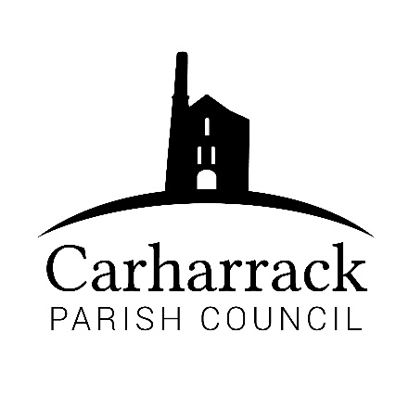 | Carharrack Parish Council
 | Parish Clerk: Joanna Picton
Sparry Farm
Sparry Bottom
Carharrack
TR16 5SH
Tel: 01209 822631

E: carharrackparishcouncil@gmail.com
W: www.carharrackparishcouncil.co.uk
12th July 2021
TO ALL MEMBERS OF THE COUNCIL
I hereby give notice that the Ordinary Council Meeting of Carharrack Parish Council will be held on Monday 13th September 2021 at The Mills Hall, Carharrack at 6pm.

All Members of the Council are hereby summoned to attend for the purpose of considering and resolving upon the business about to be transacted at the meeting as set out hereunder.

If possible, please contact the clerk to express your interest in attendance to help comply with the current covid restrictions. Please use hand sanitiser provided and wear a face mask.
Yours faithfully,
Joanna Picton
Joanna Picton, Parish Clerk

AGENDA
- Persons Present/Apologies - To NOTE persons present and RECEIVE any apologies for absence.
- Chair welcome
- Declarations of Interest from Members/Dispensations
To RECEIVE any Declarations of Interest from Members. To RESOLVE to grant any requests for Dispensation in line with the New Councillor Code of Conduct 2021 if appropriate.
- Public Participation
To RECEIVE comments from members of the public. This provides an opportunity for members of the public to comment on items on the agenda as per Standing Orders or otherwise considered at the Chairman’s discretion. Maximum time allowed will total 10 minutes/2 mins per person.
- Cornwall Councillors Report Update on current issues from C.C. Connor Donnithorne
- Council Meeting Minutes for the meeting held on 19th July 2021
To RESOLVE that the above Minutes of the Meetings of Carharrack Parish Council having been previously circulated, be taken as read, approved, and signed. To NOTE any matters arising from the Minutes.

- AUDIT – to receive and note the Internal Auditor’s Report 2020/21
- AUDIT – to agree and sign the Annual Governance Statement 2020/21
- AUDIT – to agree and sign the Accounting Statements 2020/21
- DIRECT DEBITS – to consider setting up Direct Debits
- FINANCE – to include finance report and payments for approval

- Finance: To approve:
- Salaries for Clerk and RFO
- Reimbursements for Cllr Constable and Cllr Aldridge

- Planning:
PA21/06640 Sues Field Sparry Lane Carharrack Redruth Cornwall TR16 5SJ

- The playing field toilet facilities- Helen Mulhern invited to speak. Review of the portaloo. Options for 2022.
- Climate Action Group - Cllr Garbett & Cllr Holland -Green Walkabout in Carharrack
- Roving Banners Update
- Peat Free Village
- Mining Villages Regeneration Group Meeting - Cllr Chown to feedback
- Allotment AGM - Cllr Aldridge to feedback
- Code of Conduct Training – compulsory for Parish Councillors
- Agenda Items - To NOTE any items for the next Parish Council meeting schedule for:
Monday 18th October 2021

