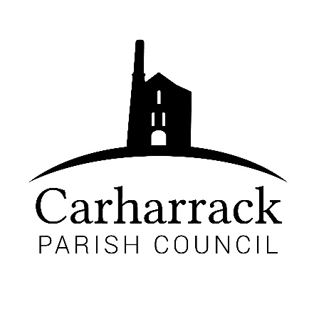 | Carharrack Parish Council
 | Parish Clerk: Joanna Picton
Sparry Farm
Sparry Bottom
Carharrack
TR16 5SH
Tel: 01209 822631

E: carharrackparishcouncil@gmail.com
W: www.carharrackparishcouncil.co.uk
30 July 2026
TO ALL MEMBERS OF THE COUNCIL
I hereby give notice that the Ordinary Council Meeting of Carharrack Parish Council will be held on Monday 21st June 2021 at The Mills Hall, Carharrack at 6pm.

All Members of the Council are hereby summoned to attend for the purpose of considering and resolving upon the business about to be transacted at the meeting as set out hereunder.

If possible, please contact the clerk to express your interest in attendance to help comply with the current covid restrictions. Please use hand sanitiser provided and wear a face mask.
Yours faithfully,
Joanna Picton
Joanna Picton, Parish Clerk

AGENDA
1. Persons Present/Apologies - To NOTE persons, present and RECEIVE any apologies for absence.
2. Chair welcome
3. Declarations of Interest from Members / Dispensations
To RECEIVE any Declarations of Interest from Members. To RESOLVE to grant any requests for Dispensation in line with the Councillor Code of Conduct 2012 if appropriate.
4. Public Participation
To RECEIVE comments from members of the public. This provides an opportunity for members of the public to comment on items on the agenda as per Standing Orders or otherwise considered at the Chairman’s discretion. Maximum time allowed will total 10 minutes/2 mins per person.
5. Cornwall Councillors Report Update on current issues from C.C. Connor Donnithorne
6. Council Meeting: Minutes from April 2021 Zoom meeting and May ACM 2021
To RESOLVE that the above Minutes of the Meetings of Carharrack Parish Council having been previously circulated, be taken as read, approved, and signed. To NOTE any matters arising from the Minutes.

7. Traffic update - To DISCUSS the updates received about the Traffic at the Pound crossroads.
- Pavement Parking- Cllr Aldridge to discuss
- Presentation from Philip Ladd - proposed development of land in Carharrack
9. Allotments – Update from Cllr Aldridge
- Open Day
- Review of the annual fees 2021-22
- 4year plan
10. Co-opted Vacancy - To DISCUSS, APPROVE and APPOINT as appropriate
11. Defibrillator
To APPROVE the site offered for the new defibrillator.
- St. Day and Carharrack Climate action group- Update from Cllr Garbett
- Adoption of the Climate Action Plan
13. Mining Villages Regeneration Group – Update from Cllr Martin
14. Parish Magazine Review-
- Printing, Costs and Delivery
- Delivery Rounds and Volunteers
15. Planning applications:
- Conversion of workshop to annex with noncompliance with Condition 2 in relation to decision notice relating to Myloria, Carnmarth Cove, Carnmarth, Carharrack
Ref. No PA21/05376
- 35 Tresithney Road Carharrack TR16 5QZ
Ref. No: PA21/04689
- Land West of Chenhale Farm Chenhale Carharrack Cornwall TR16 5RB
Ref. No: PA21/03521

16. Finance - to APPROVE the financial statement and the following invoices for payment
- Clerks Salary, Expenses and Reimbursements - Laminator, Laptop with Windows Business package and additional printing costs
- RFO Salary
- HMRC Payment
- Allotment Expenses and Repairs to Allotment Shed

- Footpaths Officer

- Agenda Items - To NOTE any items for the next Council meeting – Monday 19th July 2021

- Public Bodies (Admission to Meetings) Act 1960
To RESOLVE that in view of the confidential nature of the business about to be transacted it is advisable that the press and public be excluded and are instructed to withdraw during the discussion of the following item:
- Clerk finances

