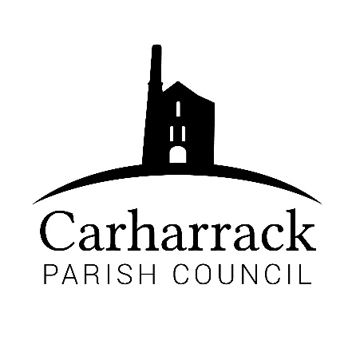 | Carharrack Parish Council
 | Parish Clerk: Joanna Picton
Sparry Farm
Sparry Bottom
Carharrack
TR16 5SH
Tel: 01209 822631

E: carharrackparishcouncil@gmail.com
W: www.carharrackparishcouncil.co.uk
30 July 2026
TO ALL MEMBERS OF THE COUNCIL
I hereby give notice that the Ordinary Council Meeting of Carharrack Parish council will be held on Monday 14th December 2020 via zoom commencing at 6.45pm.

All Members of the Council are hereby summoned to attend for the purpose of considering and resolving upon the business about to be transacted at the meeting as set out hereunder.

Any members of the public wishing to join the meeting please contact the clerk.
Yours faithfully,

Joanna Picton

Joanna Picton, Parish Clerk

AGENDA
- Persons Present/Apologies
To NOTE persons, present and RECEIVE any apologies for absence.
- Chair welcome
- Declarations of Interest from Members / Dispensations
To RECEIVE any Declarations of Interest from Members. To RESOLVE to grant any requests for Dispensation in line with the Councillor Code of Conduct 2012 if appropriate.
- Councillors Report: Update on current issues from C.C. Mark Kaczmarek

- Public Participation
To RECEIVE comments from members of the public. This provides an opportunity for members of the public to comment on items on the agenda as per Standing Orders or otherwise considered at the Chairman’s discretion. Maximum time allowed will total 10 minutes/2 mins per person.
- Geothermal Distillery
Presentation from the Geothermal distillery and an opportunity to ask questions.
- Council Meeting: Minutes From 23rd November 2020 Zoom meeting
To RESOLVE that the above Minutes of the Meetings of Carharrack Parish Council having been previously circulated, be taken as read, approved and signed. To NOTE any matters arising from the Minutes.
- Plot 48 Allotment site-
To DISCUSS options
- Planning Applications:
Application: PA20/04337
Proposal: Change of use of part of field for access from highway to Mount Pleasant
Location: Mount Pleasant Woodbine Hill Carnmarth Carharrack Applicant Mr & Mrs Zeat-Kane
- Park upgrade- DISCUSS provisional plans, presentation
- Finance (regular) – to approve invoices for payment
- Clerks Salary and expenses/reimbursements
- RFO salary
- Banking Arrangements- To DISCUSS the current bank accounts and RESOLVE the next stages
- Park Stenak Amenity area- To DISCUSS the latest information
- LMP Tender –
- To DISCUSS how to move forward with applications
- To APPROVE contractor for Tender
- Items for agenda:
To NOTE any items for the next Council meeting.

