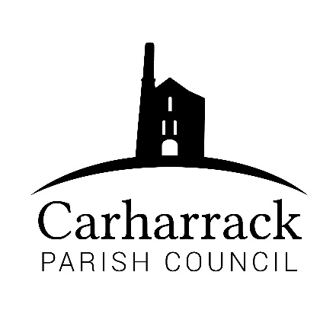 | Carharrack Parish Council
 | Parish Clerk: Joanna Picton
E: carharrackparishcouncil@gmail.com
W: www.carharrackparishcouncil.co.uk

10th February 2022
TO ALL MEMBERS OF THE COUNCIL
I hereby give notice that the Ordinary Council Meeting of Carharrack Parish Council will be held on Monday 21st February 2022 at The Mills Hall, Carharrack at 7pm.

All Members of the Council are hereby summoned to attend for the purpose of considering and resolving upon the business about to be transacted at the meeting as set out hereunder.

If possible, please contact the clerk to express your interest in attendance to help comply with the current covid restrictions. Please use hand sanitiser provided and wear a face mask in accordance with Government regulation.

Yours faithfully,
Joanna Picton
Joanna Picton, Parish Clerk
AGENDA

- Persons Present/Apologies - To NOTE persons present and RECEIVE any apologies for absence.

- Chair Welcome

- Declarations of Interest from Members/Dispensations
To RECEIVE any Declarations of Interest from Members. To RESOLVE to grant any requests for Dispensation in line with the New Councillor Code of Conduct 2021 if appropriate.

- Public Participation
To RECEIVE comments from members of the public. This provides an opportunity for members of the public to comment on items on the agenda as per Standing Orders or otherwise considered at the Chairman’s discretion. Maximum time allowed will total 10 minutes/2 mins per person.

- Cornwall Councillors Report Update on current issues from C.C. Connor Donnithorne

- Parish Council Meeting Minutes for the meeting on 24th January 2022

To RESOLVE that the above Minutes of the Meetings of Carharrack Parish Council having been previously circulated, be taken as read, approved, and signed.
To NOTE any matters arising from the Minutes.

- Finance-
- Reimbursements for Stationary
- Clerks’ salary, home working allowance and reimbursement for website
- Invoices for training from CALC
- Source for business water bill for the allotments
- National allotments society subscription

Clerk to Update councillors on the requirements to appoint an external auditor for end of year accounts.

- Noticeboards- To DISCUSS a proposed site for a new Parish Council/Community Noticeboard. Consider any other options for the purchase and installation of a new noticeboard.
- Queen's Platinum Jubilee - Report on public responses and DISCUSS and APPROVE a budget to support events and/or activities. To include report from ICE meeting – Cllr Aldridge/Cllr Chown

- LMP- To DISCUSS the Local Maintenance Partnership agreement for the cutting of the parish footpaths and bridleways and consider tenders from contractors for the 2022 year. To APPROVE a new contractor for the LMP.

- The Pound Field - DISCUSS and APPROVE the initial stages for the reinstatement of the Pond and consider and approve quotation(s) received.

- Bus Shelter Cleaning - To APPROVE quarterly cleaning and maintenance for the two bus shelters.

- Report from St Day & Carharrack Climate Action Group – Cllr Garbett and Cllr Holland to report to council

- Report from Geothermal Webinar Update – Cllr Garbett to report to council

- Agenda Items - To NOTE any items for the next Parish Council Meeting

