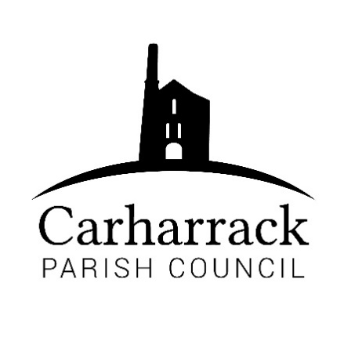 | Carharrack Parish Council
 | Parish Clerk: Joanna Picton
E: carharrackparishcouncil@gmail.com
W: www.carharrackparishcouncil.co.uk

Ordinary Parish Council Meeting Minutes – 22nd November 2021 (OM22/11)
6.45pm start held at the Mills Hall Carharrack

- Persons present: Chair Cllr Holland, Vice Chair Cllr Chown, Cllr Constable, Cllr Aldridge, Cllr Clarke, Cllr Martin, Cllr Garbett. Clerk Mrs. J Picton. 2 Members of the public.
- Chair welcome- Chair thanks everyone for attendance and welcomes everyone to the meeting.
- Declarations of interest PA21/10887-Cllr Clarke. Football grant Cllr Chown.
- Public participation. Member of the public speaks on behalf of a planning application for a client. Question: Is it a suitable place for a house or not? Land has a walled garden, open on one side for an access route. Neighbors have been concerned, and comments made. Dwelling to dwelling overlooking, connected to the settlement. Design, height, and location. Loss of privacy. Design not confirmed but access needs to be widened. Squire lane would be changed to facilitate this. All issues raised will be dealt with by CC. Undecided to know if it is a one or 2 story dwelling. Self-build proposal, family member looking to build home and be a permanent resident.
- PA21/10440 Discussion about location and who would be affected, positives because it is for a permanent residence. No objections as long as neighbours considerations are taken in to account.
PA21/10292 Chair asks Cllr Garbett about the application as it is close by. Location is well outside the area. Caravans left on site have not been cared for. Site does not look well cared for, will need to be cleared. If it means that the site is cleared, then this may have a positive outcome. Cllr Clarke, are they asking for retrospective permission? Cllr Martin, there is already an official traveler’s site in the area, do they need another site? The applicant is claiming it has been used as a traveler’s site for 12 years, but can they prove this has been used. Discussion ensues following the shared information.
Proposed: The existing number of caravans to remain. Opposed: To not encourage more caravans to be able to come to the site. Proposal: PC would like more information about the application. Serious concerns on longer term plans for the site. Cllr Martin: To the best of CPC knowledge this site has not been used as a traveler’s site for the past 12 years this has been apparently used. They don’t think this claim is true, can they prove this? Could the quarry land up as a dumping ground for the empty caravans. Could the site owner then please come to clear this site as the ones there are not habitable. Site should not be left as it is.
PA21/10887: Application has been submitted before but has come back with changes. Original application was to build 3 houses on the plot, it had previously been objected to. Then 2 houses, objected to. Discussion of the past application by Cllr Martin.
Proposal: No objections to this application.
- Finance:
- Approve Mills Hall: Amount: £500 Proposed by-Cllr Constable Seconded by- Cllr Aldridge. Proposed by Cllr Martin £400 seconded by Cllr Clarke. With any further request for money open.
- ICE Group- £254.70 Proposed by- Cllr Clarke Seconded by- Cllr Chown
Football Club- Can be re-applied for after April 1st, 2022
- Approve increase in Clerks contracted hours. Clerk left the meeting 19.50. Then returned at 19.54.
- Proposed by Cllr Aldridge, seconded by Cllr Chown to approve the following payments/invoices:
- Salaries- APPROVED
- HMRC- APPROVED
- Work at the Pound- APPROVED
- Local maintenance partnership, verges, the Shute, Pound field- APPROVED
- Magazine payment- APPROVED
- Software package- Proposed Cllr Garbett Seconded by Cllr Constable.
- Motion to authorize new administrators- Proposed by Cllr Clarke, Seconded by Cllr Chown.
- Agenda Items- A sign for the Pound field.

Meeting closed at: 20:04

