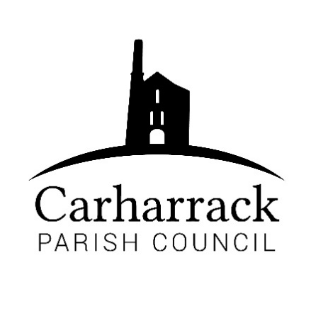 | Carharrack Parish Council
 | Parish Clerk: Joanna Picton
E: carharrackparishcouncil@gmail.com
W: www.carharrackparishcouncil.co.uk

Ordinary Parish Council Meeting Minutes – 21st November 2022 OM21/11
7pm start held at the Mills Hall Carharrack
DRAFT MINUTES

- Present- Cllrs: Holland, Chown, Aldridge, Payne, Constable, Garbett. Clerk Mrs J Picton
Apologies CC Donnithorne, Cllr Clarke.
2. Chair Welcome-Chair welcomes all to the meeting.
3. Declarations of interest-Cllr Aldridge-Mills Trust
4. Public Participation-Chenhale hedges need trimming, one member of the public asks if that’s possible. Clerk to report.
5. Cornwall councilors report- CC Donnithorne absent.
6. Parish council meeting Minutes- all in agreement. Matters arising, quote needed for the Pound field. Clerk to ask for a quote for the work and materials.
7. Bus Shelters-Cllr Aldridge reports- the posters for the bus shelters are in hand. Cllr Aldridge is hoping to liase with CC Donnithorne. Councilors worried about the high winds damaging the shelter with the broken glass. Proposed to have the large stickers on the glass to protect it. Perspex panel to replace the broken glass. 20 is plenty sticker to go onto the bus shelter to start campaign. Cllr Aldridge to gain quotes for stickers. Proposer for Perspex panel – Cllr Holland, Seconded Cllr Constable.
Cllr Aldridge offers to clean the bus shelters again as there is a lack of interest from local contractors. Cllr Aldridge to ask other councilors to help. Clerk to contact glass company for Perspex replacement for the glass.
8. Mayor for Cornwall- Cllr Holland leads the conversation about how to respond. Cllrs discuss the options for having a Mayor. What would the effect on the residents be?
“The Mayor of Cornwall is not appropriate at the time, when there are more important concerns that CC should be addressing. The cost of a referendum would be a significant drain on the county’s resources.”

9. Noticeboards- Cllr Aldridge and Cllr Chown went to see the noticeboards. Cllr Chown suggested to have a pin board for local residents. Cllr Chown would like to keep the remaining noticeboards. The new noticeboard is for the Parish council business. There is a need for a community one as well. Proposed to have 2 new noticeboards for the community. 8 A4 sheet size, clerk to obtain quotes. Poster to say where the defibrillator is to go onto new noticeboard.

10. Warm spaces- Clerk reports to the council to suggest they support a warm space for the community. Cllr Holland has spoken with members of groups in the community to support each other in the community to have a permanent warm space on different days in each community. To share spaces with St. Day. The parish council can support a warm space, can help to fund a group in the village.

11. Civility Policy- Cllr Holland leads, explaining the policy to council. Important to have it in place. The policy encourages people to be respectful of each other, council to adopt the policy. All in favor to adopt the policy.

12. Report from MVRG- Cllr Holland reports to council. New boards proposed for the main mining trail Portreath to Devoran and Great flat lode. Idea to link with CC and to have new noticeboards relevant to the site. There would be a QR code and it shows graphics to see the underneath of our mining trails. Educational and informative for the local community and tourists. They would all link to the trails all over. There will be a draft for the boards, and it will be moved forward, and funding will be needed. The chair suggests that the parish council could make a leaflet for the village.

13. Allotments- Cllr Aldridge reports- many successes at the allotments over the year, including harvest festival, many events. 90 plots that are being looked after. New rules, any shed needs a gutter and water butt. Encouraging a pond for wildlife, even a small bucket. No more poly tunnels allowed to be put up. Cllr Aldridge and Cllr Holland to do a site visit. 15 people in the allotment body group. Christmas party for the allotment holders. The allotments have been such a wonderful place for the holders the last few years, has played a huge part of their lives during lockdown.

14. Remembrance Day- Cllr Holland reports to council. A wreath was laid by Cllr Holland in the center of the village on the cross outside of the church and the church also laid a wreath and then CC Donnithorne. Cllr Holland asks if the council would like to expand on the event and work with the church. Cllr Aldridge would like to support this. Cllr Chown asks if there could be an advert in the magazine to crochet poppies for next year. Councilors would like to organize something for the next Remembrance Day.
15. Planning applications- PA22/09468: No objections.
16. Finance- Total amount-£1184.04 Proposed by- Cllr Chown, Seconded by- Cllr Aldridge.
The new budget for 2023-2024 is discussed with councilors. The councilors discuss the magazine costs as the increase in costs in printing is growing. Clerk to look at printing costs, advert costs to rise slightly.
All in agreement with the draft budget for 2023-2024, council to adopt the budget for the next year.

17. Agenda items- The Pound.
18. AOB- message from CC Donnithorne. Magazine quotes.
19. To note, MVRG meeting 1st December at the Mills Hall 2-4pm.
20. Meeting closes at 20.30 by chair.

