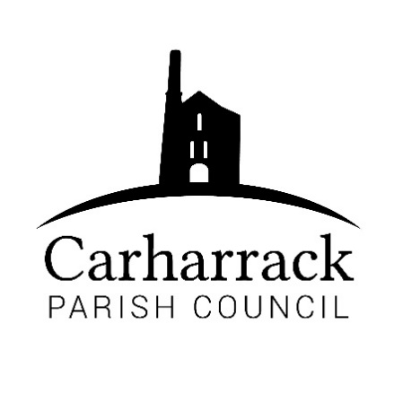 | Carharrack Parish Council
 | Parish Clerk: Joanna Picton
E: clerk@carharrackparishcouncil.co.uk
W: www.carharrackparishcouncil.co.uk

Ordinary Parish Council Meeting Minutes – 20th March 2023 OM20/03
7pm start held at the Mills Hall Carharrack
DRAFT MINUTES

- Persons Present/Apologies- Apologies: Cllr Holland, Cllr Aldridge, Cornwall councillor Connor Donnithorne. Present: Cllr Garbett, Cllr Constable, Cllr Payne, Clerk- Mrs J Picton
- Chair Welcome and acceptance of the standing order and code of conduct- Cllr Garbett chairs the meeting, The Standing orders and Code of Conduct are accepted by Council.
- Council to elect a new Vice Chairperson- To defer to the next meeting.

- Declarations of Interest from Members/Dispensations – None

- Public Participation- None present.

- Cornwall councillors report- Cllr Garbett read the report to the councillors.

- Thanks to Val Chown for service to the community
- Pound Junction to be in place in 2024
- Carharrack will be included in the 20mph rollout
- Is supporting concessionary bus fares

- Parish council meeting minutes- minutes Proposed- Cllr Constable and Seconded- Cllr Payne, all in agreement. Matters arising- to be discussed through the agenda.

- Community Accessible Noticeboards- Clerk needs to pay for the landownership information from the government website to move on with purchasing the noticeboards. Council to Approve a payment to the land ownership. Proposed - Cllr Payne and Seconded- Cllr Garbett.

- Finance-
- Clerks’ salary, home working allowance plus any reimbursements
- Payments due via direct debit invoice: Website £19.99 + £2.40
- Ratify payments to Control Print for the magazine and Trebilcock, approved.
- End of Financial year report- Read by Cllr Garbett.
- Total- £1483.33

Proposed-Cllr Garbett and Seconded- Cllr Payne
Resolved-Cllr Constable to help oversee the finances.

- Defibrillators- Clerk has secured a location at St. Piran’s church. The parish council offer thanks to the church for their kind offer.
- Audit- Councillors approve the internal auditor Proposed- Cllr Payne and Seconded- Cllr Garbett.
- Agenda Items for April- Note any items- Vice chair election, Kings Coronation.
- AOB- None

Meeting closed by Cllr Garbett at 20:10

