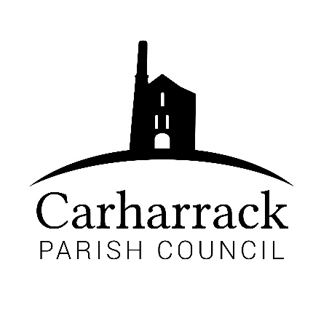 | Carharrack Parish Council
 | Parish Clerk: Joanna Picton
E: carharrackparishcouncil@gmail.com
W: www.carharrackparishcouncil.co.uk

6th January 2022
TO ALL MEMBERS OF THE COUNCIL
I hereby give notice that the Ordinary Council Meeting of Carharrack Parish Council will be held on Monday 24th January 2022 at The Mills Hall, Carharrack at 7pm.

All Members of the Council are hereby summoned to attend for the purpose of considering and resolving upon the business about to be transacted at the meeting as set out hereunder.

If possible, please contact the clerk to express your interest in attendance to help comply with the current covid restrictions. Please use hand sanitiser provided and wear a face mask in accordance with Government regulation.

Yours faithfully,
Joanna Picton
Joanna Picton, Parish Clerk
AGENDA

- Persons Present/Apologies - To NOTE persons present and RECEIVE any apologies for absence.

- Chair Welcome

- Declarations of Interest from Members/Dispensations
To RECEIVE any Declarations of Interest from Members. To RESOLVE to grant any requests for Dispensation in line with the New Councillor Code of Conduct 2021 if appropriate.

- Public Participation
To RECEIVE comments from members of the public. This provides an opportunity for members of the public to comment on items on the agenda as per Standing Orders or otherwise considered at the Chairman’s discretion. Maximum time allowed will total 10 minutes/2 mins per person.

- Cornwall Councillors Report Update on current issues from C.C. Connor Donnithorne

- Parish Council Meeting Minutes for the meeting on 13th December 2021

To RESOLVE that the above Minutes of the Meetings of Carharrack Parish Council having been previously circulated, be taken as read, approved, and signed.
To NOTE any matters arising from the Minutes.

- Defibrillator- To ADVISE meeting of price increase and associated costs for a new defibrillator. Decision to be made on how to proceed.

- The Queens Platinum Jubilee- Councillors to DISCUSS and APPROVE plans to mark this commemoration within the community.

- Maintenance in The Pound field- Cllr Garbett to DISCUSS

- Finance-
- Reimbursements for Stationary and allotments
- Clerks’ salary, home working allowance and reimbursement for website
- Invoice for Ash Tree felling
- Invoice for Allotment tree felling and hedge cutting in Sparry Lane
- Payment to Cornwall council
- Maintenance payment for the defibrillator

Update on the requirements to appoint an external auditor for end of year accounts

Appointment of Parish Councillor for internal quarterly audit inspections for 2022/23 financial year. Councillors to APPROVE a councillor to be the inspector.

- Planning- PA21/09415 Proposed residential dwelling and detached double garage.
Location Land Southwest of Grove Vista, Trevarth Road, Trevarth, Carharrack.

- Noticeboards-Cllr Holland to report to council about the village noticeboards

- Litter Picking – Consideration of Areas of Responsibility Scheme. Date for Spring Litter Pick.

- Report from CPIR and Mining Villages Network Panel Meeting - feedback from the last meeting

- Agenda Items - To NOTE any items for the next Parish Council Meeting

