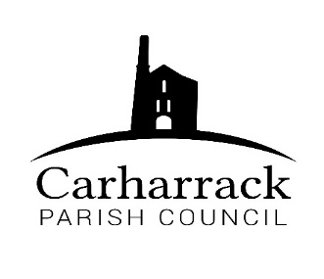 | Carharrack Parish Council
 | Parish Clerk: Joanna Picton
E: carharrackparishcouncil@gmail.com
W: www.carharrackparishcouncil.co.uk

12th June 2022
TO ALL MEMBERS OF THE COUNCIL
I hereby give notice that the Ordinary Council Meeting of Carharrack Parish Council will be held on Monday 20th June 2022 at The Mills Hall, Carharrack at 7pm.

All Members of the Council are hereby summoned to attend for the purpose of considering and resolving upon the business about to be transacted at the meeting as set out hereunder.

If possible, please contact the clerk to express your interest in attendance to help comply with the current covid restrictions. Please use hand sanitiser provided and wear a face mask in accordance with Government regulation.

Yours faithfully,
Joanna Picton
Joanna Picton, Parish Clerk
AGENDA

- Persons Present/Apologies - To NOTE persons present and RECEIVE any apologies for absence.

- Chair Welcome

- Declarations of Interest from Members/Dispensations
To RECEIVE any Declarations of Interest from Members. To RESOLVE to grant any requests for Dispensation in line with the New Councillor Code of Conduct 2022 if appropriate.

- Public Participation
To RECEIVE comments from members of the public. This provides an opportunity for members of the public to comment on items on the agenda as per Standing Orders or otherwise considered at the Chairman’s discretion. Maximum time allowed will total 10 minutes/2 mins per person.

- Cornwall Councillors Report Update on current issues from C.C. Connor Donnithorne

- Parish Council Meeting Minutes for the meeting on Monday 24th April and Monday 16th May 2022

To RESOLVE that the above Minutes of the Meetings of Carharrack Parish Council having been previously circulated, be taken as read, approved, and signed.

To NOTE any matters arising from the Minutes.

- Toilets for the playing field- A report from Cllr Holland. To DISCUSS and APPROVE hire for the summer holidays.
- Bus Shelter glass replacement- To DISCUSS and APPROVE the options available
- Magazine- Costs and advertising, councillors to DISCUSS and APPROVE
- Park Stenak- Report from Cllr Holland
- Harvest festival/village scarecrow competition- Allotment Site-Discuss and agree financial support
- To Note- Insurance renewal letter
- Summer holidays- To DISCUSS and APPROVE an activity for the summer holidays for the community

- Finance-
- Clerks’ salary, home working allowance and reimbursement for website
- Contactor invoice for grass cutting- £40
- Loo cleaning- £36
- Reimbursement for stakes- £8 for Cllr Holland
- To ratify payments that needed to be paid before the meeting: Health and safety work to the Pound Pond: £1472.74 Cormac-£471.71. Water bill-£187.22. Portreath Garden Machinery-£36.60. Control Print-£652.00.
- Reimbursement for allotment costs- £12.51 plus £20.49 for paper towels

- Agenda Items - To NOTE any items for the next Parish Council Meeting

