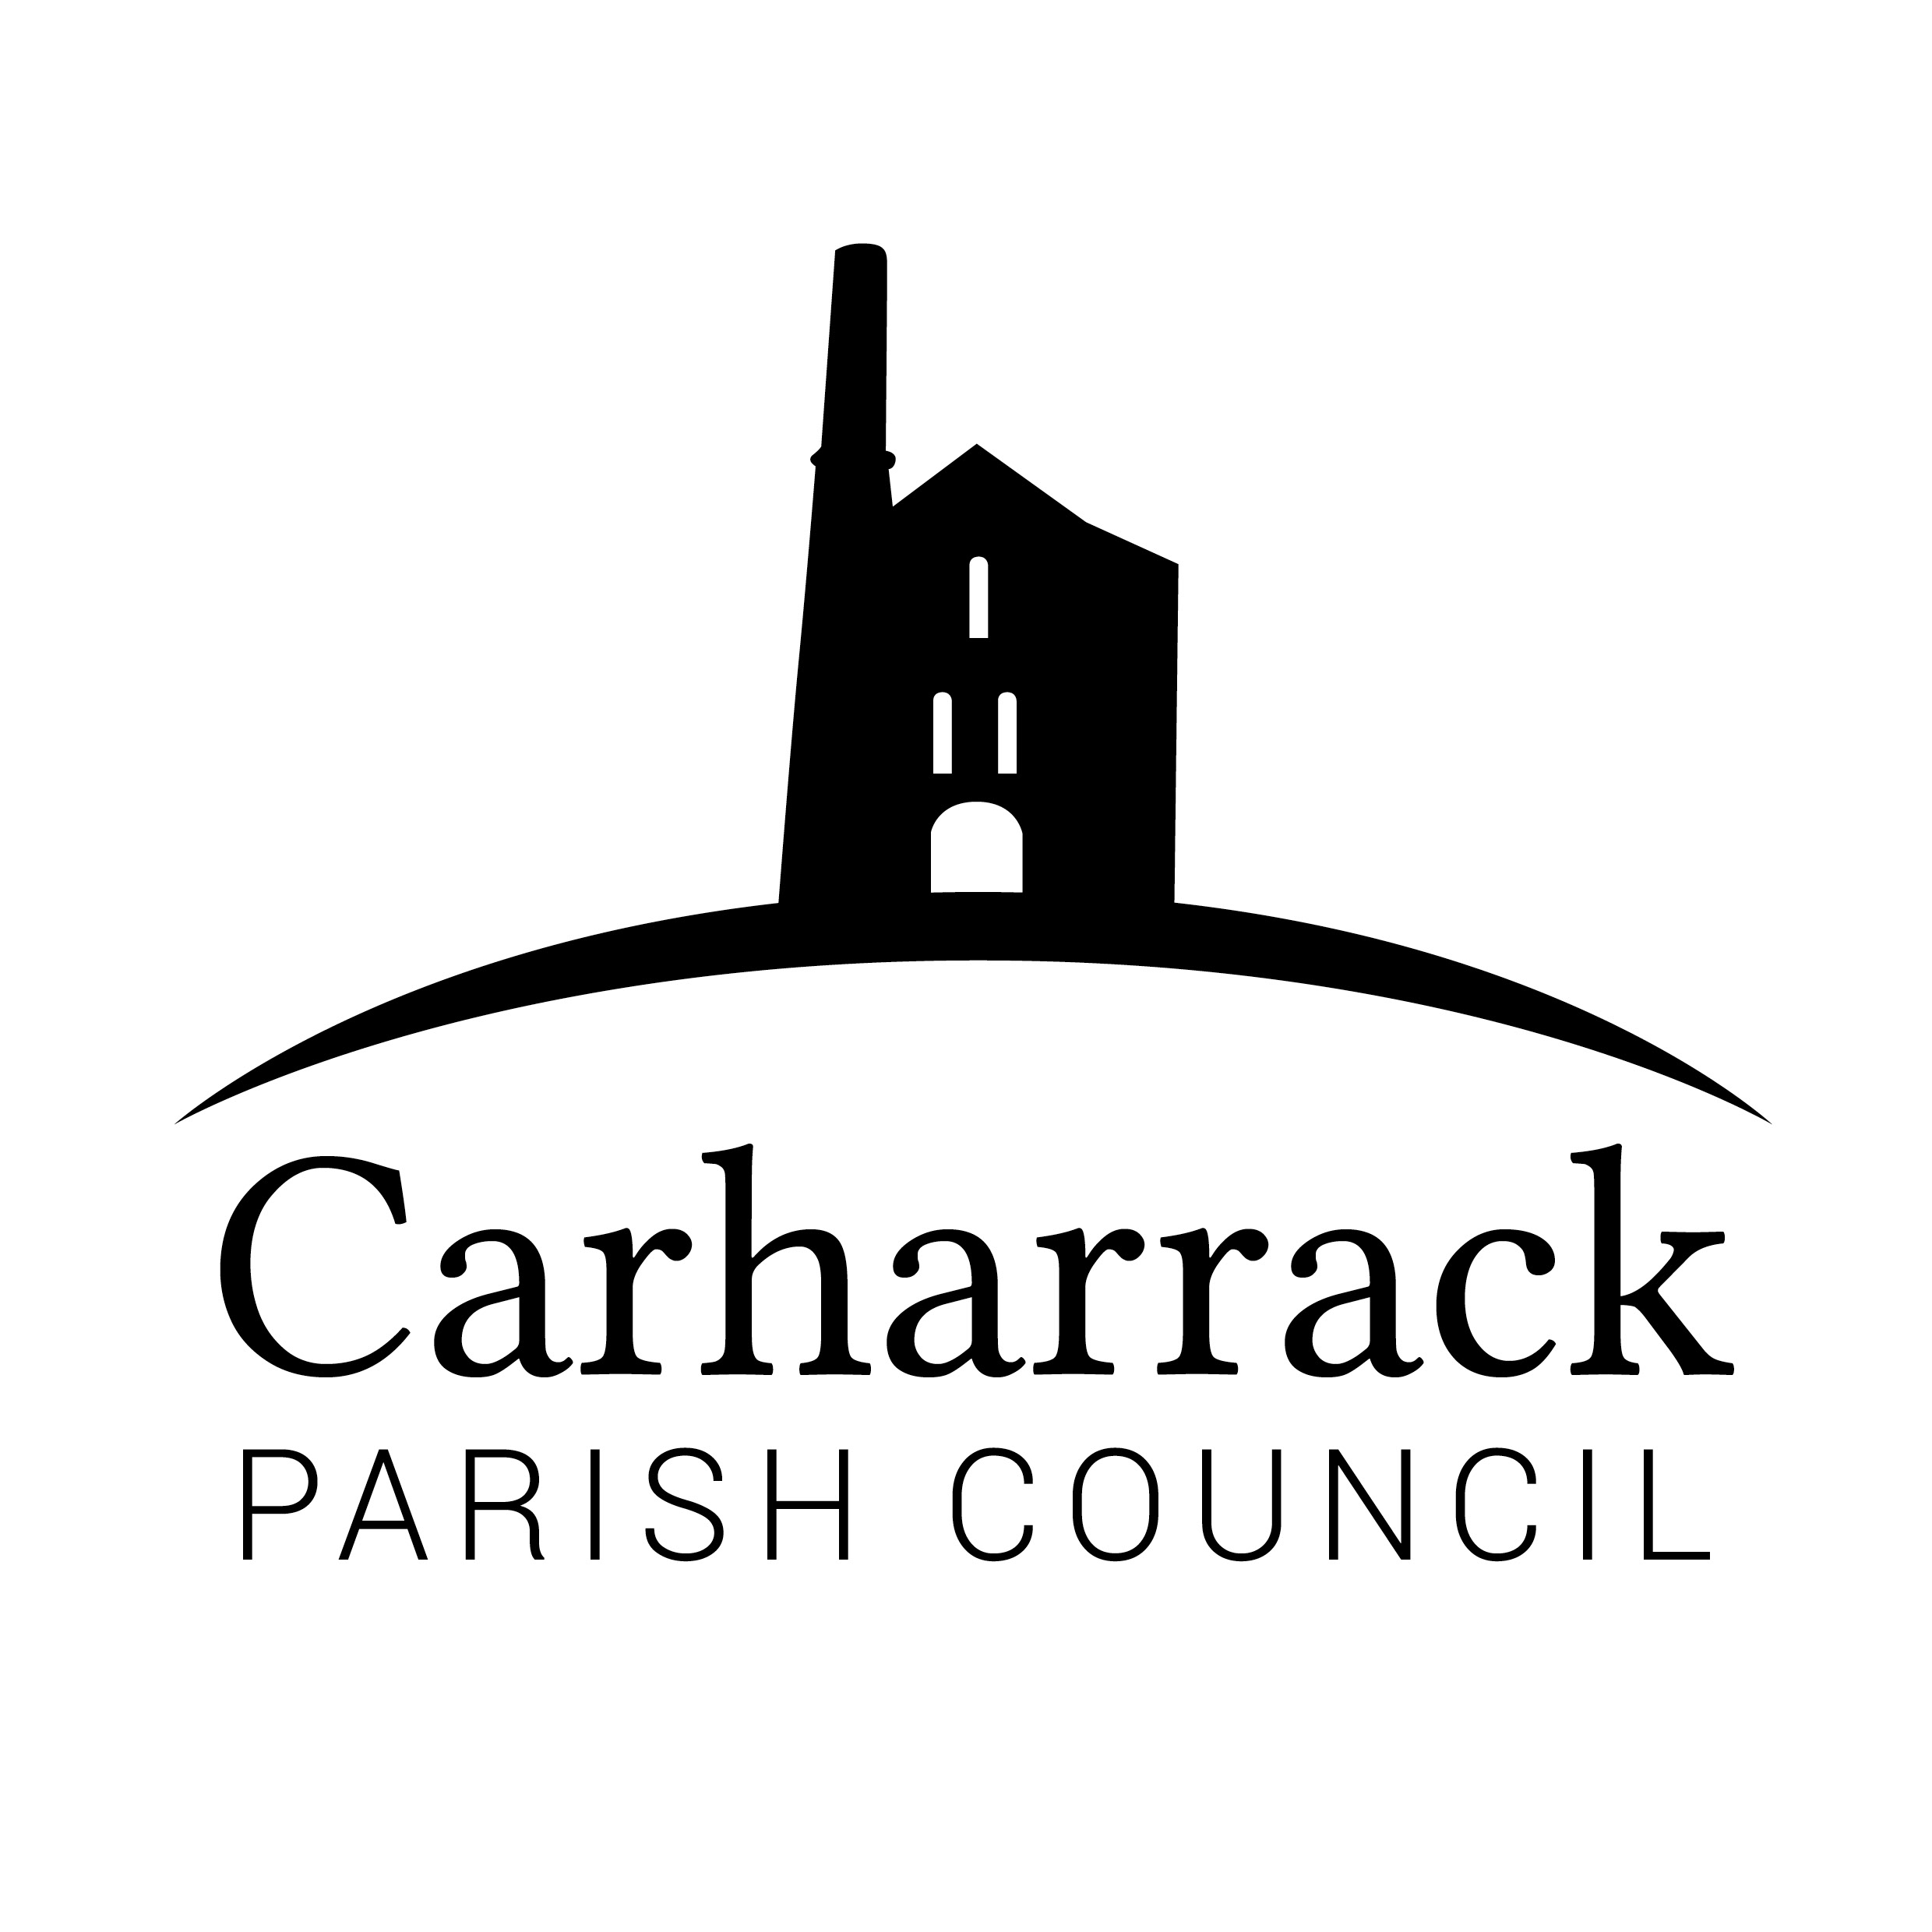
Carharrack Parish Council Grant Application Form

This form must be fully completed and forwarded to the Parish Clerk, Applications can be submitted, and will be considered by the Parish Council, at any time during the year.

Name of Organisation
Charity Number (if applicable)
Contact Name
Contact Telephone Number
Contact Email address
Contact Address

- Please state below a short description of your organisation and its aims and objectives

- Please give details of your group membership including the geographical area covered and percentage of membership from Carharrack Parish.

- Have you received a grant from Carharrack Parish Council in the past? Yes / No
If the answer is Yes, please state the year of the last grant and how much you were awarded

Year |  | Amount awarded

- If you provided details of previous grant payments, please provide details of how this grant was used. This information will be useful to members of the Parish Council in making their decision for this year. The Parish Council reserves the right to request proof of this statement.

- Please provide as much information as possible as to why you are applying for a grant and specifically what the funding, if granted, would be used for. Note that if a grant is approved, such funding must only be used for the agreed purpose. Written permission must be obtained from the Parish Council to change the use of any awarded funding.

- If you are applying for funds to improve a building please state how many people, and which other organisations, if any, use the premises.

- How much are you applying for?

Amount

- Are you applying for a grant from any other organisations? No
- If you answered Yes to question 8, please provide details below (organisation, £ applied for/awarded).

- Please state how much funding your organisation is contributing towards this project or scheme
Amount

I hereby declare that the answers and statements that I have made are, to the best of my knowledge, true. I understand that legal action could be taken against either myself or the organisation I represent if I knowingly provided false information in an effort to gain public funds.

 | Signatory 1 | Signatory 2
Signed
Designation in Organisation
Date

Checklist
All sections of the application form have been completed
A copy of any relevant documentation pertaining to this grant application is attached to the form (e.g. quote)

For Official Use Only

Parish Council Decision
Date of decision |  | Date Grant Paid
Signed
Clerk for the Council Chairman of the Council
Upon grant approval, the Clerk is hereby authorised to process the grant payment.
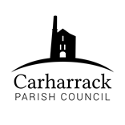
Carharrack Parish Council Grants Policy

Introduction, Guidance and Interpretation

- Carharrack Parish Council welcome applications for grants from voluntary groups or charitable organisations operating for the benefit of Carharrack Parish. The Parish Council has a budgeted sum of money that it can award each year to local groups.

- To qualify for an award, the applicant(s) must be able to demonstrate, via a Grant Application Form, that any funding from Carharrack Parish Council will benefit the Parish or residents of the Parish.

- This Grants Policy has been adopted by Carharrack Parish Council to clarify its desire to support local groups and to enhance community wellbeing and social interaction of a distributed community.

- In this Grants Policy:
“Applicant” means the persons or group applying for the grant

“Closing Date for Grant Applications” is the date publicised by the Clerk of the Parish Council, and included at the top of the Grant Application Form. This date is non-negotiable. Applications received after this date will not be considered.

“Member(s)” includes an elected member and/or a co-opted member of the Parish Council

- Grant applications will be considered by the full Parish Council at their March meeting, immediately following the Annual Meeting of the Electors. Grant applicants are encouraged to attend the Annual Meeting of the Electors to verbally support their grant application and answer questions from members of the Parish Council.
- Grants of between £50 - £500 will be awarded.
- In determining the validity of an application, the Parish Council will refer to the following guidelines:

Applications will be considered for the following purposes:

- For the purpose of purchasing equipment either in part or in full.
- For projects seeking to enhance parish facilities or improve parish cohesion.
- For the funding of transport that will enable group members to partake in a group trip or outing regardless of their incomes.
- For training activities, or to purchase the expertise of an outside trainer/ instructor/ facilitator.
- For activities that raise the profile of the area.
- For running costs of a viable group that is experiencing a period of hardship.
- For hosting special events or celebrations.
- For the provision of recreational facilities.

Conditions:

- Grants will not be awarded to individuals, and will normally only be accepted from non profit making organisations, societies or groups
- All applications must be accompanied by the Council’s Grant Application Form which must be fully completed. The Council reserves the right to refuse any application form which is not fully completed.
- Requests for funds should be clearly seen to benefit a group of people within Gwennap Parish.
- Additional applications within a 12-month period will not normally be considered.
- Grant applications should be for specific projects and not for the general running costs of an organisation, unless the group is experiencing a period of hardship.
- The award must be used for the purpose for which the application was made. Written permission must be obtained from the Parish Council before the money is spent if you wish to change the use of the funds. If written permission is not obtained, Carharrack Parish Council have the right to demand that all or some of the monies be returned to the Parish Council.
- All awards must be properly accounted for and evidence of expenditure should be supplied if requested. If Carharrack Parish Council is not satisfied with the arrangements, they reserve the right to request a total or part refund of monies awarded.
- Carharrack Parish Council reserves the right to withhold any agreed grant until such time as satisfactory invoices or evidence of the project can be presented to the Council.
- Donations to Registered Charities in response to a general fundraising appeal will be restricted to an upper limit of £100
- Any grant awarded by Carharrack Parish Council may be subject to additional conditions as determined by the Council.

Eligibility:

- Any not for profit charity, voluntary group or community organisation.
- Applications from schools will be considered for extra curriculum activities/resources.
- Groups that operate within the Carharrack Parish boundary and are of benefit to the local community, with the following provisos:
- Carharrack Parish Council will not fund activities that it considers to be the responsibility of a Statutory Authority.
- Carharrack Parish Council will not fund activities outside its powers and functions.

Submission and Closing Date for Applications:
Completed application forms can be submitted, and will be considered by the Parish Council, at any time during the year.

Completed application forms can be posted, or emailed to the Clerk at clerk@carharrackparishcouncil.co.uk

Clerk,
C/O 8 Albion Row,,
Carharrack,
Redruth,
Cornwall.
TR16 5QW

Successful applicants may be invited to a Parish Council meeting to give a short presentation on how the funds were used and the impact the grant has had.

