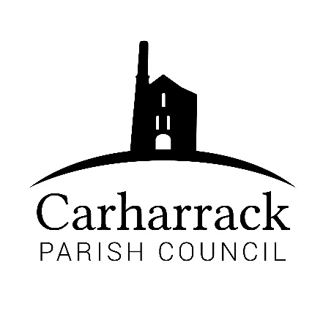 | Carharrack Parish Council
 | Parish Clerk: Joanna Picton
Sparry Farm
Sparry Bottom
Carharrack
TR16 5SH
Tel: 01209 822631

E: carharrackparishcouncil@gmail.com
W: www.carharrackparishcouncil.co.uk
29 July 2026
TO ALL MEMBERS OF THE COUNCIL
I hereby give notice that the Ordinary Council Meeting of Carharrack Parish council will be held on Monday 21st September 2020 via zoom commencing at 6.45pm.

All Members of the Council are hereby summoned to attend for the purpose of considering and resolving upon the business about to be transacted at the meeting as set out hereunder.

Any members of the public wishing to join the meeting please contact the clerk.
Yours faithfully,

Joanna Picton

Joanna Picton, Parish Clerk

AGENDA
- Persons Present/Apologies
To NOTE persons, present and RECEIVE apologies for absence.
- Chair welcome and welcome to Ellie Pearson new Parish Councillor
- Declarations of Interest from Members / Dispensations
To RECEIVE any Declarations of Interest from Members. To RESOLVE to grant any requests for Dispensation in line with the Councillor Code of Conduct 2012 if appropriate.
- Public Participation
To RECEIVE comments from members of the public. This provides an opportunity for members of the public to comment on items on the agenda as per Standing Orders or otherwise considered at the Chairman’s discretion. Maximum time allowed will total 10 minutes/2 mins per person.

- Council Meeting: Minutes From 17th August 2020 Zoom meeting
To RESOLVE that the above Minutes of the Meetings of Carharrack Parish Council having been previously circulated, be taken as read, approved and signed. To NOTE any matters arising from the Minutes.
- Councillors Report
To read Prior to the meeting and to DISCUSS any issues arising
- Verge Cutting, footpaths and Grass cutting
To RECEIVE information from Highways. DISCUSS and APPROVE a process to source a contractor to be hired as discussed at the last meeting.
To CONSIDER the employment of a litter picker/maintenance person on a weekly basis
- Weed Clearance
Cllr Garbett to DISCUSS and council to RESOLVE how to go forward
- Correspondence/Finance - TO APPROVE
- Correspondence- Open letter from Millie Buist on the Facebook Carharrack social page, councillors to receive letter prior to meeting and to DISCUSS and APPROVE donation of £350
- Correspondence- A Thank you from St Day and Carharrack Climate Action Group
- Invoice-From Bu-Mar skip hire APPROVE cheque
- Clerks Salary and overtime- cheques to be APPROVED
- Reimbursement- to Ccllr Holland for Stationery and disposal of confidential waste to be APPROVED
- Invoice- Tomas Hill consultancy cheque to be APPROVED
- Finance- Budget monitoring report- to be presented by financial advisor Tomas Hill
- Allotments –
- To DISCUSS quotes from the tree surgeons and to APPROVE which contractor to go forward with, quotes to be sent via email for councillors to read before the meeting
- To APPROVE a new notice board for the allotment site
- To DISCUSS the purchase of a trailer for future disposal of waste from the allotment site
- Planning-
RESOLVE-Planning Application: PA20/07346 Demolition of existing dwelling and construction of a replacement dwelling. – Tresco, Carnmarth, Carharrack TR16 5SB
PA20/07432 | Construction of one detached dwelling, one detached domestic garage and alterations to an existing vehicle access onto an existing vehicle access lane [Amended Siting to current development approved within PA19/07884]. | Valley View Little Carharrack Carharrack TR16 5RS
- Park Stenak area of amenity land – To DISCUSS and APPROVE how to proceed after councillors have visited the site prior to the meeting
- Grants/Donations
To DISCUSS and APPROVE grant applications submitted to the Parish Council
- Carharrack sports and social club
- Carharrack football club

- Poppy Wreath- DISCUSS and APPROVE to have a wreath in the village for Remembrance Day

- Items for agenda:
To NOTE any items for the next Council meeting.
- Public Bodies (Admission to Meetings) Act 1960
To RESOLVE that in view of the confidential nature of the business about to be transacted it is advisable that the press and public be excluded and are instructed to withdraw during the discussion of the following item:
- Council to discuss Clerk wages- in accordance to new wage rise NALC salary grade list

