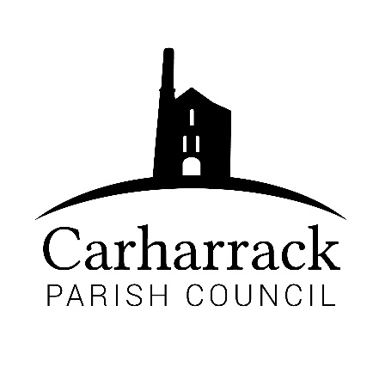 | Carharrack Parish Council
 | Parish Clerk: Joanna Picton
Sparry Farm
Sparry Bottom
Carharrack
TR16 5SH
Tel: 01209 822631

E: carharrackparishcouncil@gmail.com
W: www.carharrackparishcouncil.co.uk
29 July 2026
TO ALL MEMBERS OF THE COUNCIL
I hereby give notice that the Ordinary Council Meeting of Carharrack Parish Council will be held on Monday 19th April 2021 via zoom commencing at 7.15pm.

All Members of the Council are hereby summoned to attend for the purpose of considering and resolving upon the business about to be transacted at the meeting as set out hereunder.

Any members of the public wishing to join the meeting please contact the clerk.

Join Zoom Meeting
https://us02web.zoom.us/j/88206449620?pwd=WHJQZm5xdGlKcU5sbTcwN0xrUE9CQT09
Meeting ID: 882 0644 9620
Passcode: 155792

Yours faithfully,
Joanna Picton
Joanna Picton, Parish Clerk

AGENDA
1. Persons Present/Apologies - To NOTE persons, present and RECEIVE any apologies for absence.
2. Chair welcome
3. Declarations of Interest from Members / Dispensations
To RECEIVE any Declarations of Interest from Members. To RESOLVE to grant any requests for Dispensation in line with the Councillor Code of Conduct 2012 if appropriate.
4. Public Participation
To RECEIVE comments from members of the public. This provides an opportunity for members of the public to comment on items on the agenda as per Standing Orders or otherwise considered at the Chairman’s discretion. Maximum time allowed will total 10 minutes/2 mins per person.
5. Cornwall Councillors Report Update on current issues from C.C. Mark Kaczmarek
6. Council Meeting: Minutes From 22nd March 2021 Zoom meeting
To RESOLVE that the above Minutes of the Meetings of Carharrack Parish Council having been previously circulated, be taken as read, approved, and signed. To NOTE any matters arising from the Minutes.
7. The Pound Information sign - To DISCUSS and APPROVE a sign for the Pound.
8. Allotments
Update from Cllr Aldridge regarding the allotments
“Welcome to our Village” Planters at both entrances to the village
9. Litter Picking - To DISCUSS and APPROVE a date for a litter pick in the village.
10. Defibrillator
To DISCUSS and APPROVE a new defibrillator for the community.
11. Footpaths & Bridleways
Parish Council Footpath Officer
BHS Bridleways & Access Officer
Circular Routes and Accessibility for Mobility Scooters
12. Elections
Updates for the election, location, and date of the May meeting for DISCUSSION
13. Cornwall Association of Local Councils (CALC)
To DISCUSS renewal of CALC Annual Subscription
14. Speed and village traffic
Brief discussion
15. Finance - to APPROVE the following invoices for payment and financial statement.
Clerks Salary, Expenses, and any Reimbursements due
RFO Salary
Reimbursement to Cllr Aldridge for the allotments
HMRC Payment
Reimbursement to Cllr Holland for VE sign, envelopes, drawing pins and laminating pouches.
16. Mining Trails Leaflets
Consider suitable location for display/availability of leaflets for trail users.
17. Cornwall Council/Utilities Companies Notification of Scheduled Works
18. Planning- Application PA21/02968 Location: Gershoms Ark Wheal Damsel Road Carharrack Redruth Applicant: Mr And Mrs N Hutchings
19. Agenda Items - To NOTE any items for the next Council meeting – Monday 24th May 2021

