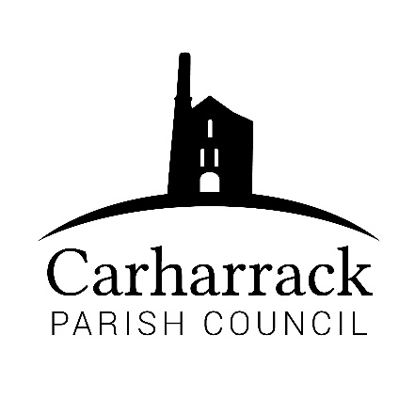 | Carharrack Parish Council
 | Parish Clerk: Joanna Picton
Sparry Farm
Sparry Bottom
Carharrack
TR16 5SH
Tel: 01209 822631

E: carharrackparishcouncil@gmail.com
W: www.carharrackparishcouncil.co.uk
30 July 2026
TO ALL MEMBERS OF THE COUNCIL
I hereby give notice that the Ordinary Council Meeting of Carharrack Parish council will be held on Monday 19th October 2020 via zoom commencing at 6.45pm.

All Members of the Council are hereby summoned to attend for the purpose of considering and resolving upon the business about to be transacted at the meeting as set out hereunder.

Any members of the public wishing to join the meeting please contact the clerk.
Yours faithfully,

Joanna Picton

Joanna Picton, Parish Clerk

AGENDA

- Persons Present/Apologies
To NOTE persons, present and RECEIVE apologies for absence.
- Chair welcome
- Declarations of Interest from Members / Dispensations
To RECEIVE any Declarations of Interest from Members. To RESOLVE to grant any requests for Dispensation in line with the Councillor Code of Conduct 2012 if appropriate.
- Councillors Report: Mark Kaczmarek to speak about his work in the community

- Public Participation
To RECEIVE comments from members of the public. This provides an opportunity for members of the public to comment on items on the agenda as per Standing Orders or otherwise considered at the Chairman’s discretion. Maximum time allowed will total 10 minutes/2 mins per person.

- Council Meeting: Minutes From 21st September 2020 Zoom meeting
To RESOLVE that the above Minutes of the Meetings of Carharrack Parish Council having been previously circulated, be taken as read, approved and signed. To NOTE any matters arising from the Minutes.
- The Pound
Cllr Garbett to provide up-date on the site and begin discussions on its future maintenance and use
to DISCUSS and council to RESOLVE how to go forward
- Correspondence/Finance - TO APPROVE
- Correspondence- Thank you letter from the ICE group
- Invoice-From Enviro Weed control
- Invoice- Tony Mitchell: allotment work
- Invoice- Portreath Garden Machinery
- Clerks Salary and expenses- to be APPROVED
- Reimbursement- to Cllr Holland to be APPROVED
- Reimbursement- to Cllr Aldridge to be APPROVED
- Allotments –
- To DISCUSS quotes from the tree surgeons and to APPROVE which contractor to go forward with, quotes to be sent via email for councillors to read before the meeting
- To APPROVE the purchase of a trailer for future disposal of waste from the allotment site, a budget for the trailer to be set. CLERK to report to council
- Planning-
RESOLVE-Planning Application: Barns Sunrise Hill Higher Trevethan Carharrack Cornwall
Ref. No: PA20/07018
Mount Pleasant Woodbine Hill Carnmarth Carharrack TR16 5SA
Ref. No: PA20/04337

- Park Stenak area of amenity land – Cllr Chown to report to council the findings of the questionnaires
- Maintenance Contracts for 2021 – CONSIDER and REVIEW proposed contracts for tender
- Grants/Donations
To DISCUSS and APPROVE grant applications submitted to the Parish Council
- Application from Pastor Graham Homer
- Poppy Wreath- Arrangements for the presentation of the wreath. Council to APPROVE template for the community to make and display poppies

- Items for agenda:
To NOTE any items for the next Council meeting.
- Public Bodies (Admission to Meetings) Act 1960
To RESOLVE that in view of the confidential nature of the business about to be transacted it is advisable that the press and public be excluded and are instructed to withdraw during the discussion of the following item:
- Council to discuss employment of assistant clerk- in private

