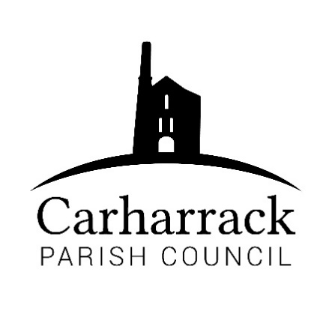 | Carharrack Parish Council
 | Parish Clerk: Joanna Picton
E: carharrackparishcouncil@gmail.com
W: www.carharrackparishcouncil.co.uk

Ordinary Parish Council Meeting Minutes – 20th June 2022 OM20/6/22
7pm start held at the Mills Hall Carharrack
DRAFT MINUTES

- Persons Present/Apologies Cllrs Chown, Clarke, Martin, Garbett and Holland. Vanessa Luckwell and one member of the public.
Apologies - Cllr Aldridge and CC Connor Donnithorne

The Chair informed the meeting that under Section 85 of the 1972 Local Government Act the non attendance at a Parish Council meeting for 6 months by Cllr Constable has created a vacancy. All in agreement to declare the vacancy and begin the necessary process.

2. Chair Welcome
Chair welcomed everyone to the meeting and advised that the clerk was on her way. Vanessa would be invited to speak to the meeting between items 4 and 5 on the agenda

3. Declarations of Interest from Members/Dispensations
None

4. Public Participation
Member of the public and representative of the Social Club asked why the advert from the Social Club has been removed from the Parish Magazine. Possibly due to non-payment. Cllr Garbett would always welcome a report or list of events for the diary, but he does not receive any response to his emails to the Social Club. This will be investigated, and we look forward to a revised advert for our next magazine. He also reported the lack of work carried out by Cornwall Council recently on the area of land by the bus shelter. Only the pathway was strimmed and the usual cutting back and clearance was not undertaken. Local residents are now using this area to discard garden waste. This will be reported by the clerk.

Vanessa Luckwell is the replacement Community Link Officer. She gave an overview of her role. She would like to receive a list of the Parish Councillors email addresses to enable her to up-date her data base. Clerk to supply please. Concerns raised regarding vandalism, anti-social behaviour and difficulties making reports to the police. An area of bamboo in the playing field is acting as a screen and needs to be cut down. Vanessa is available to provide guidance, support and assist with any forthcoming projects that the Parish Council or community would like to run for the village. So please get in touch.

Clerk arrived at the meeting and continued with the minutes.

- Cornwall Councillors Report Update on current issues from C.C. Connor Donnithorne read out to the parish council by the chair. Highways improvements priority for Carharrack. Anti-social behaviour reported late at night by the bus stop. ICE group thanked for their hard work. Levelling up missions, parish councillors invited to the 6th July meeting CNPM. Discussion ensues between councillors.

- Parish Council Meeting Minutes for the meeting on Monday 24th April and Monday 16th May 2022

To RESOLVE that the above Minutes of the Meetings of Carharrack Parish Council having been previously circulated, be taken as read, approved, and signed.

To NOTE any matters arising from the Minutes- the contractor for the covered bench has been called again.
Proposer Cllr Chown, seconded Cllr Clarke. All in agreement.

- Toilets for the playing field- A report from Cllr Holland. To DISCUSS and APPROVE hire for the summer holidays. The toilet was in the playing field for the Jubilee and half term. A local cleaner took on the role for cleaning again. Was vandalised sadly. Chair provided stakes to be held down. Chair received a phone call from a member of the public to say there were 3 young people tampering with the portaloo. Chair then went to ask the group of people to stop. It was reported to the police and Gwennap Parish council. They are known to Gwennap parish council for vandalism. Parish council to approve the toilets for the summer holidays. All in favour of booking the toilets for the summer. Passed.

- Bus Shelter glass replacement- Councillors discuss the options for the replacement of the glass. All in agreement to leave the broken pane there as it is continuously vandalised. Until the parish council can think of another option, to be discussed again at the next meeting.

- Magazine- Costs and advertising. Cllr Garbett discusses the current situation with the magazine. A discussion ensues about the magazine. It is appreciated by the community. Budget for the magazine to be looked at in the autumn. To continue with prices for another year. To review the budget and review in September. All in favour- passed.

- Park Stenak- Cllr Holland reports to the parish council. Cllr Holland and Cllr Aldridge and 2 members of the climate action group went to the Park Stenak site. They received a hostile reception from the community members that turned up. The decision has been made to not pursue land ownership. Solicitor and owners of the land have been contacted. Discussion ensues about the land. Resolved not to take any further action in obtaining land ownership and the parish council to leave the land to be maintained by current owners.

- Harvest festival/village scarecrow competition- Allotment Site-Discuss and agree financial support. Saturday 5th September at 2pm. Refreshments and food to be collected for the food bank TBC. Reverend Liz, a blessing, and Hymns. Big scarecrow competition, for the community. Carharrack feed store to provide prizes. Children’s small scarecrow competition. To be brought to the allotments. Cllr Holland is requesting the parish council to support the event in costs of £90 in vouchers. Proposed by-Cllr Holland, seconded by Cllr Chown. All in agreement.
- To Note- Insurance renewal letter, signed by Cllr Holland
- Summer holidays- an activity for the summer holidays for the community. Councillors discuss the idea. Cllr Chown to look at options.

- Finance-
- Clerks’ salary, home working allowance and reimbursement for website
- Contactor invoice for grass cutting- £40
- Loo cleaning- £36
- Reimbursement for stakes- £8 for Cllr Holland
- To ratify payments that needed to be paid before the meeting: Health and safety work to the Pound Pond: £1472.74 Cormac-£471.71. Water bill-£187.22. Portreath Garden Machinery-£36.60. Control Print-£652.00.
- Reimbursement for allotment costs- £12.51 plus £20.49 for paper towels
- Microsoft package for parish laptop £59.99
Proposed by Cllr Chown, Seconded by Cllr Martin
All in agreement

- Agenda Items – Bus shelter glass, Pennance road.
Chair closes the meeting at 20:24

