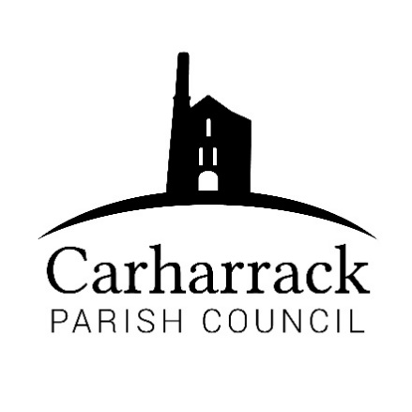 | Carharrack Parish Council
 | Parish Clerk: Joanna Picton
Sparry Farm
Sparry Bottom
Carharrack
TR16 5SH
Tel: 01209 822631

E: carharrackparishcouncil@gmail.com
W: www.carharrackparishcouncil.co.uk
Ordinary Council Meeting Minutes- 23rd November 2020
6.45pm start Held Via Zoom

- Persons Present/Apologies
Apologies from Cllr Pearson.
Present: Cllr Holland, Cllr Aldridge, Cllr Chown, Cllr Martin, Cllr Garbett, Cllr Constable
Cornwall Councill Mark Kaczmarek and 4 members of the public.
- Chair welcome- The meeting is opened with a greeting from the chair and the members of the public are welcomed.
- Declarations of Interest from Members / Dispensations
Cllr Chown – Carharrack Football Club
- Councillors Report:
Report from CC Kaczmarek had been circulated prior to the meeting. An update was provided which emphasized the work that had gone on in the village in recent weeks by both the Covid 19 Support Group and those who had set up the Food Pantry. There has been an increase in fly tipping in the area please report this to the Council if possible. Details of a planning application for a rum distillery at United Downs has been submitted. The Household Waste and Recycling Centre is due to close and this will reduce the number of vehicles in this area.
- Public Participation
John Floyd – Office of National Statistics – informed the PC about the 2021 Census. Information will be distributed, and he will be point of contact for anyone or groups of residents who may need support to complete their returns. Clerk to circulate information and send out the community handbook to CPC
Member of the public: enquiry about a Christmas competition for the parish? Cllr Garbett informed the meeting there was a section on Father Christmas in the forthcoming magazine. Discussion about the Christmas lights.

- Food Pantry- Guest talks about the food pantry, village have been proactive in setting it up and running it. Tesco have donated food; grants have been applied for. Drop off and pick up. CPC bank account to accept the grants on behalf of the group and the money given to the group for distribution for food. Discussion about the food pantry ensued.
Resolve the use of the Parish Council bank account for grant funding on behalf of the Food Pantry group: Proposer Cllr Aldridge and seconder Cllr Constable, APPROVED
- Council Meeting: Minutes From 19th October 2020 Zoom meeting: Council asked to confirm. Discussion ensued. All in agreement. Matters arising: CPC to write a letter of congratulations to Roy Trelease on his contributions to the band in Carharrack. Proposer Cllr Aldridge and seconder Cllr Chown, APPROVED.
Football club: Discussion about previous grant application. CPC buy the line marker and donate it to the football club in a couple of years. Proposer Cllr Aldridge and seconder Cllr Constable In writing with clear guidelines. APPROVED
- E-greeting-
Approved for clerk to distribute, CPC to view first and to send any email addresses to the clerk for anyone who we would like to send an e-greeting
- Correspondence
(a) Mr Scoley – Allotment Site, update provided to the meeting by Cllr Aldridge who had since spoken with Mr Scoley.
- Finance (regular) – to approve invoices for payment
Total amounts: See attached the budget monitoring report for total income and expenditure
Explanation about the extra costs of the parish magazine provided to the meeting
Propose Cllr Chown and seconder Cllr Garbett: payments APPROVED
Income | Expenditure
£0 | £3,092.65

- Budget- to agree the 2021/2022 budget: Proposer Cllr Chown and seconder Cllr Constable : APPROVED
- Precept- to agree the 2021/2022 precept: Discussion ensued. Financial officer presented the information. Proposer Cllr Chown and seconder Cllr Constable: APPROVED
- LMP Tender –
- No applications confirmed, will discuss in December meeting
- Planning-
No objections to the following:
- Planning Application Ref. No: PA20/08553 Proposed garage extension
76 Trevince Parc Carharrack Redruth TR16 5QX
- Planning Application Ref. No: PA20/09230 Two storey side extension to existing dwelling.
1 Manor House Wheal Damsel Road Carharrack TR16 5RU
Questions raised for application:
- Planning Application Ref No: PA20/08400 New Dwelling, land adjacent to Poldice Valley, Chenhale Farm
- Outline Permission granted in October 2019 – plans submitted for a 4 bedroom property. Concern expressed that it could see this area begin to develop with a change of use from agricultural land to property development land. CPC requires reassurance from planning that this is not the case.
- Items for agenda:
New quotes for allotments entrance
- It was confirmed that Millie Buist has provided an article with photographs for the Parish magazine and the clerk would make arrangements for the cheque to be forwarded for Millie's sponsorship at Plymouth Argyle Ladies Football Team.
Meeting closed: 20.00hrs

