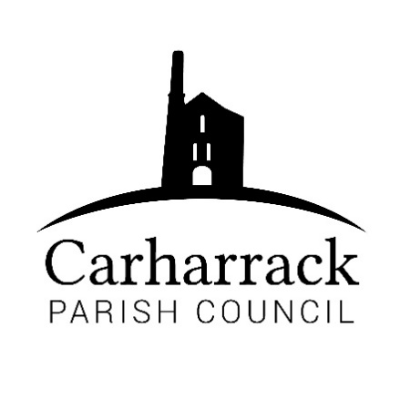 | Carharrack Parish Council
 | Parish Clerk: Joanna Picton
E: clerk@carharrackparishcouncil.co.uk
W: www.carharrackparishcouncil.co.uk

Ordinary Parish Council Meeting Minutes – 16th January 2023 OM16/01
7pm start held at the Mills Hall Carharrack
DRAFT MINUTES

- Present- Apologies: Cllrs Bettina Holland and Roger Clarke
Present: Cllrs Aldridge, Garbett, Chown, Constable. Clerk Mrs J Picton
Cornwall Councillor Connor Donnithorne
Guest: Helen Neal, Community link officer
Absent: Cllr Payne

- Chair Welcome- Vice chair welcomes all to the meeting.

- Declarations of interest- Mills Hall Trustee - Cllr Aldridge.

- Public Participation- None present.

- Cornwall councilors report - CC report – “20 is Plenty” resolve by 2030. Proposed to roll out over the whole of Cornwall. Phase 1, 2, 3. Carharrack and St. Day - Priority pound junction - news in two weeks. Brokenshire corner - on the list.

- Parish council meeting Minutes - All in agreement.

Matters ongoing – The date of the car crash at the Pound was 10:30 p.m. on 15th of November. To Approve the gates and fence maintenance quote from the contractor - proposed by Cllr. Chown, seconded by Cllr. Constable.

Helen Neal - Community network officer. Helen is introduced to the meeting by the Vice Chair. Helen has extensive knowledge about Carharrack. Discussed is the “20 is plenty” stakeholder groups in March. The consultation to devolution community network panel 7th of February 2023.
There will be an extra virtual meeting online Wednesday 25th of January – for one hour. Public events one at Redruth 6:30 p.m. Wednesday 18th of January.
Community network areas will be changing in May.

- Bus Shelters - defer to next meeting to get a better idea of material and costs.

- LMP - still not received. Reported that Squires Lane is overflowing - not accessible manhole. Report to Cornwall Council about Sparry Lane.

- Planning- PA22/10355 - Parish Council opposed this application due to access requirements and it could potentially be substandard accommodation.
PA22/10314 - Discussion about the plans ensues. No objection from Carharrack Parish council.

- Finance- December finances ratified- Proposed by- Cllr. Chown, Seconded by- Cllr. Aldridge
January finances- Proposed by Cllr. Constable, Seconded by Cllr. Aldridge.
Councillors discuss the donation to the Carharrack and St. Day school trip, from December. Councillors agree to donate £300 to the school. Proposed by Cllr. Constable, Seconded by Cllr. Garbett
Allotments - all in agreement for works to be carried out.

14) Report from the Mining Villages Regeneration Group Meeting- Cllr. Chown reports about the meeting. Discussion ensues about the meeting.
15) Agenda items - village benches, community access notice boards, pavement weed clearance, magazine costs and advertising costs. Remembrance Day knitted poppies many bears knitted for November.
Clerk to ask other Clarks for advertising prices for magazines. Quotes for magazines. Contact Mixam
Clerk to Invoice Cllr Aldridge for slimming world advert.

16) AOB- Cllr. Chown reports to council about the police liaison meeting on Teams.
3rd February 2 to 4 Redruth library pop-up surgery for police, John Thorne asked to attend.

Meeting closed at 8:15 p.m. by Vice Chair

