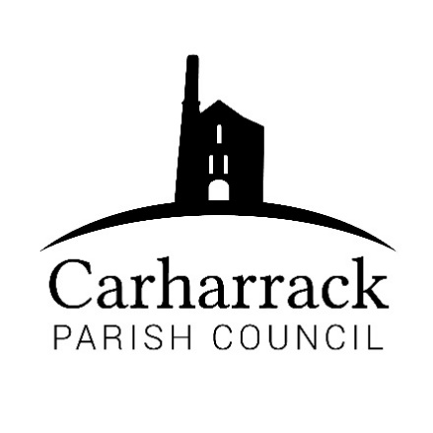 | Carharrack Parish Council
 | Parish Clerk: Joanna Picton
Sparry Farm
Sparry Bottom
Carharrack
TR16 5SH
Tel: 01209 822631

E: carharrackparishcouncil@gmail.com
W: www.carharrackparishcouncil.co.uk
9th September 2020
Ordinary Council Meeting Minutes – 17th August 2020
Held online via Zoom

Minutes from Meeting 17/08/2020
OM17/08 1. Persons Present/Apologies
Present: Cllr Holland, Cllr Garbett, Cllr Aldridge, Cllr Constable
Apologies: Cllr Martin (out of the country) and Cllr Chown (family commitment)
OM17/08 2. Declarations of Interest from Members / Dispensations: None
OM17/08 3. Public Participation: Three applicants for the Co-Opted Vacancy, Tomas Hill (Consultant to the Parish Council) and Sarah Mason (CEO of the Cornwall Association of Local Parish Councils)
OM17/08 4. Council Meeting Minutes of 24th February 2020 and 27th July 2020 (virtual meeting)
Resolved: All in agreement as a correct record.
Matter arising – agreement to source and appoint a contractor to undertake grass cutting in 2021.
OM17/08 5. Community Governance review
Resolved: Details had been circulated to all Parish Councillors prior to the meeting and all were in agreement with the small changes to the parish boundary.
OM17/08 6. Verge Cutting, Footpaths and Grass Cutting
Verge cutting: Discussion: Council requested to ask St Day and Gwennap for details of their contractor. General agreement to use local contractors wherever possible. Encourage the sharing of resources/information with neighbouring parishes to keep costs and travel time to an acceptable level.
Resolution: Clerk to contact St Day and Gwennap Parish Councils for details of their contractor.
OM17/08 7. Retention and destruction of documents
Resolved: Seconded and agreed to destroy unnecessary and excessive amounts of paperwork inherited from the previous clerk, following the legal guidelines.
OM17/08 8. Finances:
Discussion: St Day and Carharrack Climate Action Group working with The Mills Hall Trust to put forward a bid for funding to make the Mills Hall a low carbon/zero emissions building. £600 donation had been made by St Day Parish Council and the group is working within both St Day and Carharrack Parishes. All improvements to benefit both communities.
Resolution: Proposal invited by chair - £400 proposed – all agreed.
Cheques to be signed:
- £100 - Mining Villages Regeneration Group
- Cllr Garbett - Reimbursement for the printing costs for the latest edition of the parish magazine.
- Clerk – Monthly salary and expenses
- Tomas Hill – Consultancy Work
- Portreath Garden Machinery – Servicing and Repair of lawn mowers
- Cllr V Aldridge – Reimbursement for costs of minor repairs to allotment site W.C.
Resolved: Website monthly costs to be paid by Cllr Holland and reimbursement claimed
Resolved: To begin the process of having a debit card for the Parish Council to ease the payment and receipt of monies more efficiently.
OM17/08 9. Allotments:
Resolution: letter of consent to be sent to John Ealy to undertake the work at the entrance to the allotment site - all in agreement.
Resolution: General waste skip required for September - all in agreement. Cllr Aldridge and Clerk to organise
OM17/08 10. Planning
All acknowledged the withdrawn planning application: PA20/00606 5 Railway Terrace
OM17/08 11. Items to be ratified from email discussions during lockdown:
Resolved:
- Code of Conduct to be adopted by the Parish Council
- Finance Consultancy accepted and to continue
- Cornwall Association of Local Councils (CALC) membership
- Appointment of Mrs Joanna Picton to the position of Clerk
- To continue banking with HSBC – address for bank statements and correspondence will be that of the Chair for the present time. To be reviewed.
OM17/08 12. Matters arising To NOTE
OM17/08 13. Park Stenak
- Further information needed, site visit to be organised and continued discussion of plans for this area of responsibility. To be considered further at the next meeting.
OM17/08 14. Grants
- Resolution: Clerk to advertise and to send forms to applicants to be reviewed at the September meeting
OM17/08 15. Items for next agenda
- Weed Clearance – Cllr Garbett
- Tree Surgeon for Allotment Site – Cllr Aldridge
OM17/08 16. Expressions of interest for Parish Council Vacancy
Three applications had been received expressing interest for the vacancy for a co-opted Parish Councillor
All applicants were in attendance at the virtual meeting – Roger Clarke, Ellie Pearson and Justin Hinshelwood. At this stage in the proceedings each were invited in turn by the chair to speak to the members of the Parish Council.
OM17/08 17. Public Bodies Act 1960 – Recognised by all
OM17/08 18. Confidential Vote for Co-Opted Parish Council Vacancy
The result of the vote confirmed Ellie Pearson as the newly appointed co-opted Parish Councillor.
OM17/08 19. 7.55pm – The Meeting was closed by the Chair

