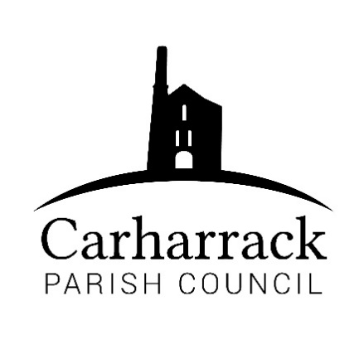 | Carharrack Parish Council
 | Parish Clerk: Joanna Picton
E: carharrackparishcouncil@gmail.com
W: www.carharrackparishcouncil.co.uk

Ordinary Parish Council Meeting Minutes – 24th October 2022 OM24/10
7pm start held at the Mills Hall Carharrack
DRAFT MINUTES

- Persons Present/Apologies - To NOTE persons present and RECEIVE any apologies for absence.
Councillors: Holland, Chown, Garbett, Clarke, Aldridge. Clerk: Mrs J Picton. New councillor’s: Constable and Payne. Apologies from CC Donnithorne

- Chair Welcome- Chair welcomes all to the meeting and welcomes the two new parish councillors. All councillors introduce themselves to the new councillors.

- Co-option of new councillors- Councillors are welcomed and asked to sign relevant forms as co-opted councillors.

- Declarations of Interest from Members/Dispensations: None

- Public Participation: None present

- Cornwall Councillors Report Update on current issues from C.C. Connor Donnithorne, CC Connor Donnithorne is absent. No report was sent.

- Parish Council Meeting Minutes for the meeting on Monday 18th July 2022 and 26th September 2022
All in agreement and accurate record.

To NOTE any matters arising from the Minutes: None

- The Allotments- Cllr Aldridge reports, the water bill was high during the hot summer. Cllr Aldridge is trying to find a more eco-friendly way to manage the water so more rainwater can be used. Proposes to buy 2 more water butts for the allotments site, at £10 each. £188.42 for the whole project. £278.42 in total. Plot holders with a shed, proposed that the sheds have guttering and a water butt. Cllr Aldridge is encouraging members of the allotments to use as much rainwater as possible. Cllr Holland suggests an article for the magazine about watering plants. For the new equipment for the allotments-Proposed Cllr Chown, seconded Cllr Clarke

- The Pound Field - Cllr Garbett reports. Unfortunately, young people are getting in and causing damage. The contractor went to check the damage. He has sourced a gate for the fence around the pond. There is a small repair needed for the main gate as well. Seems to be more litter in the area. A bin suggested for the area, but councillors are concerned it might cause more problems. Signs suggested to go up to ask people to take litter home and no access to the pond. Discussion ensues. Cllr Garbett to pursue a quote. Cllr Garbett proposes the work goes ahead. Seconded Cllr Constable.

- Noticeboards – Council to decide what to do with the existing noticeboards and the timeframe for their removal. Cllr Holland reports. The church noticeboard has been removed so it can be re-used. Cllr Holland asks what people would like to use them for. Cllr Aldridge would like to re-use the allotments noticeboard for within the allotments site. The Mills Hall noticeboard, discussion ensues, all in agreement to have it taken down. Clerk to contact Mills Hall trustees. Notice for the new board with parish councillors contacts will be on there, clerk to compile. Board at Park Stenak, it is used by the community. Discussion ensues. All in agreement.

- Bus Shelter Glass- Cllr Holland leads the discussion explaining to the new councillors the glass keeps being smashed, it costs a lot of money to keep replacing it. Cllr Holland proposes to put up a collage of photos as a sticker to put over the glass. Cllr Aldridge has designs and costings. Cllr Aldridge presents the ideas to council. Parish councillors feel the photos are a positive enhancement. Suggested by Cllr Holland to have 20 is plenty vinyl stickers on the sides of the other bus shelters in the village. Cllr Aldridge to obtain quotes for the vinyl stickers. Councillors in favour of the improvements to the bus shelters. Cllr Holland proposes that a local cleaner is contacted to ask if he would be interested in cleaning the bus shelters once a month, clerk to contact.

- Finance-
- Clerks’ salary, home working allowance plus any reimbursements
- Community funding ideas
- Village improvements
- Reimbursement to Cllr Aldridge Allotments £46.49
- Payments due via invoice: Website £19.99 + £2.40
Footpaths £456.63
Budget training £36.00
Reimbursement to Cllr Holland £4.99
MVRG subs £100
Total: £1222.18
Proposed Cllr Chown, Seconded Cllr Clarke both to authorise the payments.

- To set a budget for the year 2023-2024- Discussion ensues about the previous budget and costs. Discussion about clearing the weeds in the pavements. Making the pavements unsafe. Proposed that the contractor could come and help clear specific trouble spots. Councillors to report problems to clerk. Clerk to email about broken shires corner, road markings. Councillors discuss the budget and to keep the precept at £20,000 as not to increase council tax. Proposed Cllr Chown, Seconded Cllr Aldridge. All in agreement for £20,000.

- Remembrance Day- arrangements for wreath and display of large poppies for the community. Cllr Holland proposes to put the large poppies in the village. All in agreement.

- Agenda Items - the next Parish Council Meeting, Monday 21st November 7pm
- AOB- at the Chairs discretion, to discuss any other urgent business not available to include on the agenda at the time of its publication.
Planning applications:
PA22/08043 8 railway terrace- No objections by parish councillors.
PA22/09202 Donkey track cottage- No objections by parish councillors.
Note-Cllr Chown reports back to council from the police meeting, problems in the local park with noise 3-4am. Cllr Chown has asked police to come to see the park in the early hours. Cllr Holland, want to put out a positive message to the community. If there are issues the public to be encouraged to contact 101 or 999 in an emergency.

The chair closes the meeting at: 20:39

