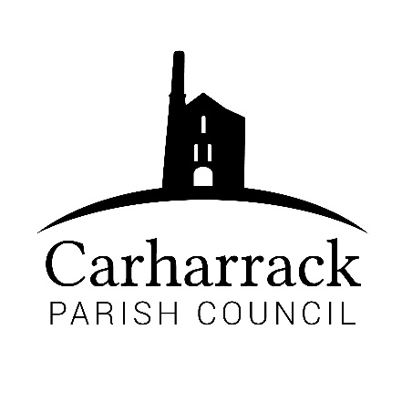 | Carharrack Parish Council
 | Parish Clerk: Joanna Picton
Sparry Farm
Sparry Bottom
Carharrack
TR16 5SH
Tel: 01209 822631

E: carharrackparishcouncil@gmail.com
W: www.carharrackparishcouncil.co.uk
29 July 2026
TO ALL MEMBERS OF THE COUNCIL
I hereby give notice that the Ordinary Council Meeting of Carharrack Parish council will be held on Monday 15th February 2021 via zoom commencing at 6.45pm.

All Members of the Council are hereby summoned to attend for the purpose of considering and resolving upon the business about to be transacted at the meeting as set out hereunder.

Any members of the public wishing to join the meeting please contact the clerk.
Yours faithfully,
Joanna Picton
Joanna Picton, Parish Clerk

AGENDA
- Persons Present/Apologies
To NOTE persons, present and RECEIVE any apologies for absence.
- Chair welcome
- Declarations of Interest from Members / Dispensations
To RECEIVE any Declarations of Interest from Members. To RESOLVE to grant any requests for Dispensation in line with the Councillor Code of Conduct 2012 if appropriate.
- Public Participation
To RECEIVE comments from members of the public. This provides an opportunity for members of the public to comment on items on the agenda as per Standing Orders or otherwise considered at the Chairman’s discretion. Maximum time allowed will total 10 minutes/2 mins per person.
- Cornwalll Councillors Report Update on current issues from C.C. Mark Kaczmarek
- Council Meeting: Minutes From 18th January 2021 Zoom meeting
To RESOLVE that the above Minutes of the Meetings of Carharrack Parish Council having been previously circulated, be taken as read, approved, and signed. To NOTE any matters arising from the Minutes.
- Localism Vision & Strategy
Report from virtual presentation attended by Cllr Holland on 25th January 2021
- Carharrack & St Day Climate Action Group
Update/Report from group
- Presentation from South Crofty Mine
- Park Upgrade/Improvements - Update from Clerk following result of recent online survey
DISCUSS and APPROVE plans for new play equipment for infants/young children
- Bus shelter Maintenance
To DISCUSS and APPROVE future cleaning and maintenance of the Parish Council Bus Shelters
- United Downs Deep Geothermal Project
Fortnightly webinars are attended by Cllr Garbett – update for Parish Councillors information
- Allotments
Update on entrance improvements – Cllr Aldridge
APPROVAL for additional invoice in respect of above works due to adverse weather conditions
APPROVAL of Allotment Society Membership
- Grant application
To CONSIDER and APPROVE grant application from the Mills Hall Trust for The Mills Hall
- Finance - to approve the following invoices for payment and financial statement
- Chance Glass – bus shelter repair
- South West Water – allotments
- (Contractor) for entrance to allotments
- (Contractor) fence at lower hedge
- (Contractor) removal of overgrown vegetation to neighbouring property
- (Contractor) additional costs incurred as per item 12 above
- Grant Application
- Allotment Society Membership
- Clerks Salary, Expenses and any Reimbursements due
- RFO Salary
- HMRC Payment
16. LMP – Local Maintenance Partnership 2021-22
APPROVAL of programme and signature of agreement form
17. Agenda Items - To NOTE any items for the next Council meeting – Monday 22nd March 2021

