]
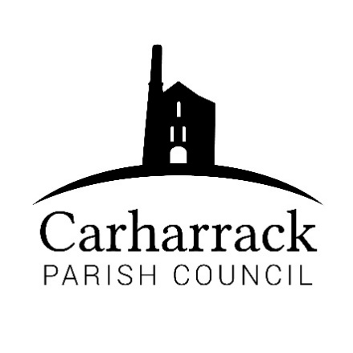 | Carharrack Parish Council
 | Parish Clerk: Joanna Picton
E: carharrackparishcouncil@gmail.com
W: www.carharrackparishcouncil.co.uk

Ordinary Parish Council Meeting Minutes – 26th September 2022 OM26/09
6pm start held at the Mills Hall Carharrack
DRAFT MINUTES

- Persons Present/Apologies – Cllrs Holland, Aldridge, Garbett, Clarke. CC Connor Donnithorne. Clerk -Mrs Picton. 1 member of the public Cllr Chown arrived at 18.33

- Chair Welcome- all welcomed to the meeting and Chair thanked everyone for their contributions. As this meeting had to be re-arrange due to the Queen's funeral the meeting was limited to time on this occasion as another group are using the hall from 7.30pm. Any items for which there is insufficient time to discuss fully will be carried over to the next meeting.

- Declarations of Interest from Members/Dispensations
Cllr Aldridge- Mills Hall Trust

- Public Participation – one member of the public asking for help with overgrown vegetation on the road. CC Donnithorne to report to Cornwall Council.

- Cornwall Councillors Report- Hedgerows and verges have been on the agenda to treat for the community, Japanese knotweed has been treated locally. Rural road inspections have declined. CC must find more funds, reviewed each year. Resident spoke to CC Donnithorne and someone came out to inspect it. Public transport, huge changes to timetables. Usage figures are low on bus routes, so they have been taken away. Trying to get younger people to college and changing the timetable. The GP surgery has had issues, the new surgery hasn’t been built. CC Donnithorne is trying to get the surgery built for the community. Community chest funding- contribution to the Carharrack football club. Mayor for Cornwall, ongoing issue.

- Parish Council Meeting Minutes for the meeting on Monday 18th July 2022

To be signed at the next meeting.

- Magazine- Parish council are going to stick to the same amount for the time being. Suggested by Cllr Chown to say what the parish council has achieved in the writing. To look at quotes for the next magazine.

- Park and the new bench- The new bench is being used by local people, and it has been cleaned by someone locally. Thank to the community for looking after it.

- The allotments- Moved to the next meeting
- Planning applications- PA22/07582- no objections
PA22/07411- 6 Manor Road- No objections
PA22/07063- Chenhale Farm- The Parish council strongly objects because: The access statement does not match the plan. The access road already has many properties using the access road, concerns for adding more vehicles to it, as it is narrow. There are always vehicles parked on the access road, which is a concern for the parish council, as it could cause an accident. There are residents who need disabled parking and carers need parking spaces. There is heavy use of this road, and the objection is that the access would not be suitable.

- Noticeboards- To be discussed at another meeting

- Bus Shelter glass- To be discussed at another meeting

- Finance-
- Clerks’ salary, home working allowance and reimbursement for website
- Payments over the break-Proposed Cllr Clarke, seconded Cllr Chown.
- Coastline medic donation £120- approved
- Reimbursement to Cllr Aldridge- approved Proposed by Cllr Holland and Cllr Chown
- Church grant application form £350- Proposed by Cllr Aldridge, seconded Cllr Chown.
- Mills Hall donation- £500 Proposed by Cllr Aldridge seconded by Cllr Chown
- Community funding and village improvements moved to the budget meeting.
August Invoices for Clerks salary, website, magazine printing, South West Water (allotments), removal of vandalised glass in bus shelter and the noticeboard in The Pound Field totally £2.202.05 were proposed by Cllr Clarke seconded by Cllr Chown

September invoices for Clerks salary, website and wreath totalling £631.68 were presented for payment. Proposed by Cllr Chown seconded by Cllr Aldridge

- Agenda Items – The topics that had to be missed at the September meeting will pass over to the next meeting.
- AOB- at the Chairs discretion, to discuss any other urgent business not available to include on the agenda at the time of its publication.
- Parish applicant decision-The clerk to make contact with each applicant and obtain phone numbers for further discussion.
Meeting closed at 19.22

