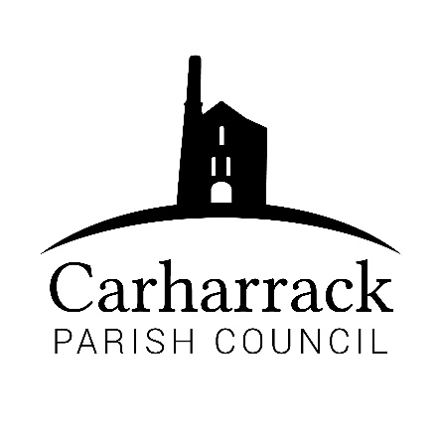 | Carharrack Parish Council
 | Parish Clerk: Joanna Picton
Sparry Farm
Sparry Bottom
Carharrack
TR16 5SH
Tel: 01209 822631

E: carharrackparishcouncil@gmail.com
W: www.carharrackparishcouncil.co.uk
31 July 2026
TO ALL MEMBERS OF THE COUNCIL
I hereby give notice that the Ordinary Council Meeting of Carharrack Parish Council will be held on Monday 22nd March 2021 via zoom commencing at 6.45pm.

All Members of the Council are hereby summoned to attend for the purpose of considering and resolving upon the business about to be transacted at the meeting as set out hereunder.

Any members of the public wishing to join the meeting please contact the clerk.

Meeting ID: 857 5080 1381 Passcode: 980946

Yours faithfully,
Joanna Picton
Joanna Picton, Parish Clerk

AGENDA
- Persons Present/Apologies
To NOTE persons, present and RECEIVE any apologies for absence.
- Chair welcome
- Declarations of Interest from Members / Dispensations
To RECEIVE any Declarations of Interest from Members. To RESOLVE to grant any requests for Dispensation in line with the Councillor Code of Conduct 2012 if appropriate.
- Public Participation
To RECEIVE comments from members of the public. This provides an opportunity for members of the public to comment on items on the agenda as per Standing Orders or otherwise considered at the Chairman’s discretion. Maximum time allowed will total 10 minutes/2 mins per person.
- Cornwall Councillors Report Update on current issues from C.C. Mark Kaczmarek
- Council Meeting: Minutes From 15th February 2021 Zoom meeting
To RESOLVE that the above Minutes of the Meetings of Carharrack Parish Council having been previously circulated, be taken as read, approved, and signed. To NOTE any matters arising from the Minutes.
- Tree distribution update
Report from Cllr Garbett regarding the recent tree distribution
- Allotments
Update from Cllr Aldridge regarding the allotments
- Shed Repairs – DISCUSS and APPROVE quote
- Hardstanding Entrance – item of correspondence
- Highway extend determination
- Park Stenak
Future Management of Amenity Land
- Dog Fouling
To DISCUSS and APPROVE the Cornwall Council dog fouling prevention scheme
- Magazine
To DISCUSS and APPROVE the quotes given for the printing of the magazine.
- Report from Cllr Chown
Feedback from the the Gypsy and Traveller Forum - Cllr Chown attended
- Defibrillator
To DISCUSS and APPROVE a second defibrillator site for the community.
- Report from Cllr Martin
Feedback from the Mining Villages Regeneration Group meeting - Cllr Martin attended
- VE DAY sign
To CONSIDER and APPROVE a sign for the community.
- Finance - to approve the following invoices for payment and financial statement.
- Clerks Salary, Expenses, and any Reimbursements due
- RFO Salary
- Reimbursement to Cllr Aldridge for the allotments
- HMRC Payment
16. Parish Council Elections
Clerk to give information regarding the upcoming elections.
17. Agenda Items - To NOTE any items for the next Council meeting – Monday 19th April 2021

