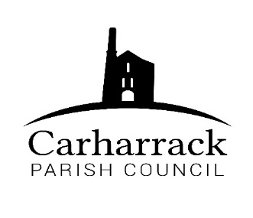 | Carharrack Parish Council
 | Parish Clerk: Joanna Picton
E: carharrackparishcouncil@gmail.com
W: www.carharrackparishcouncil.co.uk

14th April 2022
TO ALL MEMBERS OF THE COUNCIL
I hereby give notice that the Ordinary Council Meeting of Carharrack Parish Council will be held on Monday 25th April 2022 at The Mills Hall, Carharrack at 7pm.

All Members of the Council are hereby summoned to attend for the purpose of considering and resolving upon the business about to be transacted at the meeting as set out hereunder.

If possible, please contact the clerk to express your interest in attendance to help comply with the current covid restrictions. Please use hand sanitiser provided and wear a face mask in accordance with Government regulation.

Yours faithfully,
Joanna Picton
Joanna Picton, Parish Clerk
AGENDA

- Persons Present/Apologies - To NOTE persons present and RECEIVE any apologies for absence.

- Chair Welcome

- Declarations of Interest from Members/Dispensations
To RECEIVE any Declarations of Interest from Members. To RESOLVE to grant any requests for Dispensation in line with the New Councillor Code of Conduct 2021 if appropriate.

- Public Participation
To RECEIVE comments from members of the public. This provides an opportunity for members of the public to comment on items on the agenda as per Standing Orders or otherwise considered at the Chairman’s discretion. Maximum time allowed will total 10 minutes/2 mins per person.

- Cornwall Councillors Report Update on current issues from C.C. Connor Donnithorne

- Parish Council Meeting Minutes for the meeting on Monday 21st March 2022

To RESOLVE that the above Minutes of the Meetings of Carharrack Parish Council having been previously circulated, be taken as read, approved, and signed.

To NOTE any matters arising from the Minutes.

- Planning- PA22/0265137 Tresithney Road Carharrack Cornwall TR16 5QZ
Proposed new storage shed within the curtilage of an existing bungalow.

- Toilets for the playing field- To DISCUSS hire during Easter holidays and APPROVE hire for the summer holidays.

- Finance-
- Clerks’ salary, home working allowance and reimbursement for website
- CALC Membership Renewal
- Southwest Loos- remaining balance £134.00
- Payment for cleaning of portable toilet – Easter Hire

Payroll Administration – APPROVE out-sourcing of payroll administration

Park Stenak Amenity Land - Transfer of Land to Carharrack Parish Council. DISCUSS information from Thurstan Hoskin Solicitors and APPROVE costs.

- Agenda Items - To NOTE any items for the next Parish Council Meeting

