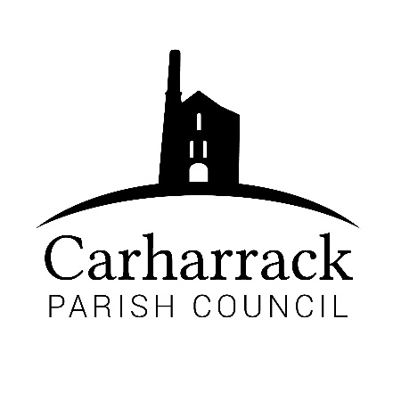 | Carharrack Parish Council
 | Parish Clerk: Joanna Picton
E: carharrackparishcouncil@gmail.com
W: www.carharrackparishcouncil.co.uk

9th March 2022
TO ALL MEMBERS OF THE COUNCIL
I hereby give notice that the Extraordinary Council Meeting of Carharrack Parish Council will be held on Monday 14th March 2022 at The Mills Hall, Carharrack at 11.30am.

All Members of the Council are hereby summoned to attend for the purpose of considering and resolving upon the business about to be transacted at the meeting as set out hereunder.

If possible, please contact the clerk to express your interest in attendance to help comply with the current covid restrictions. Please use hand sanitiser provided and wear a face mask in accordance with Government regulation.

Yours faithfully,
Joanna Picton
Joanna Picton, Parish Clerk
AGENDA

- Persons Present/Apologies - To NOTE persons present and RECEIVE any apologies for absence.

- Chair Welcome

- Proposed traffic island at The Pound junction and financial support from the Parish Council- Cornwall Councillor Connor Donnithorne to DISCUSS with Parish councillors.

Parish councillors to APPROVE decision made.

