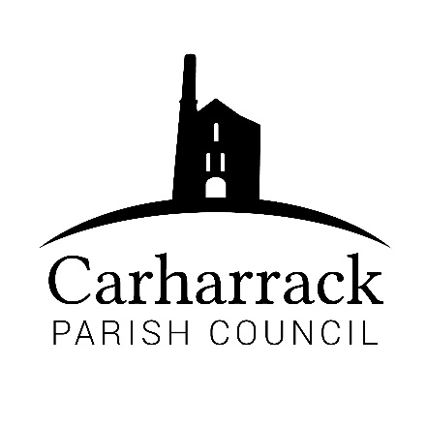 | Carharrack Parish Council
 | Parish Clerk: Joanna Picton
Sparry Farm
Sparry Bottom
Carharrack
TR16 5SH
Tel: 01209 822631

E: carharrackparishcouncil@gmail.com
W: www.carharrackparishcouncil.co.uk
29 July 2026
TO ALL MEMBERS OF THE COUNCIL
I hereby give notice that the Annual Council Meeting of Carharrack Parish Council will be held on Monday 24th May 2021 in person commencing at 6pm at the Mills Hall Car Park.

All Members of the Council are hereby summoned to attend for the purpose of considering and resolving upon the business about to be transacted at the meeting as set out hereunder.

Any members of the public wishing to attend the meeting please contact the clerk, in compliance with Covid -19 guidelines. All members of the public must wear a mask and use the sanitizer available.

Yours faithfully,
Joanna Picton
Joanna Picton, Parish Clerk

AGENDA

1. Election of Chair for Parish year 2021/2022
2. Chairpersons’ acceptance of office-to receive signed form
3. Election of Vice Chair for Parish year 2021/2022
4. Persons Present/Apologies - To NOTE persons, present and RECEIVE any apologies for absence.
5. Declarations of Interest from Members / Dispensations
To RECEIVE any Declarations of Interest from Members. To RESOLVE to grant any requests for Dispensation in line with the Councillor Code of Conduct 2012 if appropriate. For members of the Parish to make representations to the Council.
6. Appointment of members to outside bodies- to consider any appointments
7. Confirm approved standing orders, financial regulations, and other policies
8. Review inventory of land and assets
9. Review insurance cover-to check adequacy and consider the renewal
10. Review council’s membership of outside bodies-CALC
11. Finances- To APPROVE and AGREE to any payments outstanding and salaries
12. Agenda Items - To NOTE any items for the next Council meeting – Monday 21th June 2021

