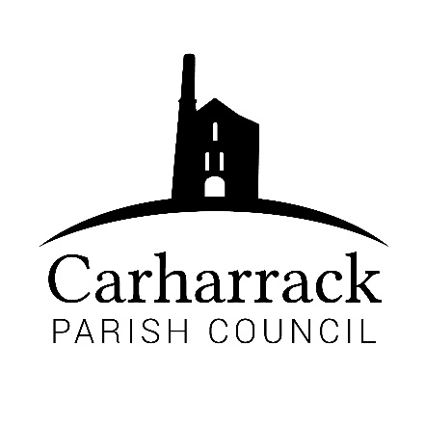 | Carharrack Parish Council
 | Parish Clerk: Joanna Picton
Sparry Farm
Sparry Bottom
Carharrack
TR16 5SH
Tel: 01209 822631

E: carharrackparishcouncil@gmail.com
W: www.carharrackparishcouncil.co.uk
29 July 2026
TO ALL MEMBERS OF THE COUNCIL
I hereby give notice that the Ordinary Council Meeting of Carharrack Parish council will be held on Monday 17th August 2020 via zoom commencing at 7.00pm.

All Members of the Council are hereby summoned to attend for the purpose of considering and resolving upon the business about to be transacted at the meeting as set out hereunder.

Any members of the public wishing to join the meeting please contact the clerk.
Yours faithfully,

Joanna Picton

Joanna Picton, Parish Clerk

AGENDA
- Persons Present/Apologies
To NOTE persons, present and RECEIVE apologies for absence.
- Declarations of Interest from Members / Dispensations
To RECEIVE any Declarations of Interest from Members. To RESOLVE to grant any requests for Dispensation in line with the Councillor Code of Conduct 2012 if appropriate.
- Public Participation
To RECEIVE comments from members of the public. This provides an opportunity for members of the public to comment on items on the agenda as per Standing Orders or otherwise considered at the Chairman’s discretion. Maximum time allowed will total 10 minutes/2 mins per person.

- Council Meeting: Minutes From 24th February meeting and 27th July Zoom meeting
To RESOLVE that the above Minutes of the Meetings of Carharrack Parish Council having been previously circulated, be taken as read, approved and signed. To NOTE any matters arising from the Minutes.
- Community Governance review
To DISCUSS the proposal that was emailed to councillors and RESOLVE and APPROVE action
- Verge Cutting, footpaths and Grass cutting
To RECEIVE information from Highways. DISCUSS and APPROVE a process to source a contractor to be hired as discussed at the last meeting.
- Retention and destruction of documents
To APPROVE the Retention, Storage and Disposal of Documentation Policy for Carharrack Parish Council. Circulated with this agenda.
- Correspondence/Finance - TO APPROVE
- request from St Day & Carharrack Climate Action Group for financial support to match that received from St Day Parish Council of £600. Details have been circulated to all by email.
- Cheques-Invoice from Mining Villages Regeneration Group
- Clerk wages and overtime + reimbursement for postage and initial website costs
- Website costs-RESOLUTION for Chair to pay via credit card then reimbursement for monthly cost of £19.99 per month
- Portreath Garden Machinery – Servicing and Repair of lawn mowers
- Cllr V Aldridge – Reimbursement for costs of minor repairs to allotment site W.C.
- To apply for a debit card on the current bank account to enable the receipt of payments to be made at the local post office. Saving time and energy costs accessing the nearest branches at either Truro or Falmouth
- Allotments –
- RESOLUTION to appoint contractor to undertake grounds work at the entrance to the allotment site following receipt and consideration of three quotations received early March 2020.
- RESOLUTION for a general waste skip to be provided on site at the end of the season for clearance of waste which was not removed prior to the lockdown. Any associated expenditure
- Planning-
NOTE-Planning Application: PA20/00606 5 Railway Terrace withdrawn
- Items to be ratified from email discussions during lockdown
- Code of Conduct - RESOLUTION to adopt the Code of Conduct circulated to all Parish Councillors.
- Finance - RESOLUTION for consultancy services from Mr Tomas Hill to assist the new clerk and chair in their roles and the transition period of Carharrack Parish Council. 50 hours maximum.
- Correspondence/Finance -RESOLUTION for Carharrack Parish Council to join the Cornwall Association of Local Parish Councils.
- Appointment of Clerk - RESOLUTION to appoint Mrs J Picton to the position of Clerk/Responsible Financial Officer from 1st May 2020 on a 6-month trial basis with a view to a permanent appointment.
- Finance - HSBC mandate. RESOLUTION to continue accounts with HSBC with existing cheque signatories with change of address for receipt of all bank statements and bank information to chair.
- Matters Arising- To NOTE information only
- NOTE-Chair has sent a request for cutting the hedge on Sparry Lane (allotment boundary hedge) to Cornwall Council. If not a C.C. area of responsibility, the Parish Council will need to source a contractor.
- Dog Waste Bins - costs have not been obtained but a site has been identified - the footpath at the bottom of Squire Lane. Any further locations identified by Parish Councillors to be advised and costs to be obtained by the clerk.
- Park Stenak area of amenity land - An enquiry has been made with the Land Registry. The area of land in question is registered under Title number CL15522 and is owned by W J Ladd (Builders) Ltd. Enquiries being made regarding legal agreement that exists whereby Carharrack Parish Council is held responsible for the up-keep of this area.
- Grants/Donations
To APPROVE that all parish organisations, groups and trusts are invited to submit a request for grants for the Council's consideration.
- Items for agenda:
To NOTE any items for the next Council meeting.
- Expression of interest from persons for Parish Councillor vacancy-
APPLICANTS invited to speak to the council meeting, providing a statement and/or reasons for applying to become a Carharrack Parish Councillor.
- Public Bodies (Admission to Meetings) Act 1960
To RESOLVE that in view of the confidential nature of the business about to be transacted it is advisable that the press and public be excluded and are instructed to withdraw during the discussion of the following item:
- Council to discuss applicants for Parish Council co-opt/casual vacancy APPROVE a new Member and RESOLVE to appoint new member if appropriate

