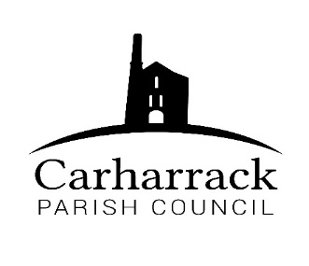 | Carharrack Parish Council
 | Parish Clerk: Joanna Picton
E: carharrackparishcouncil@gmail.com
W: www.carharrackparishcouncil.co.uk

18th October 2022
TO ALL MEMBERS OF THE COUNCIL
I hereby give notice that the Ordinary Council Meeting of Carharrack Parish Council will be held on Monday 24th October 2022 at The Mills Hall, Carharrack at 7pm main Hall.

All Members of the Council are hereby summoned to attend for the purpose of considering and resolving upon the business about to be transacted at the meeting as set out hereunder.

If possible, please contact the clerk to express your interest in attendance to help comply with the current covid restrictions. Please use hand sanitiser provided and wear a face mask in accordance with Government regulation.

Yours faithfully,
Joanna Picton
Joanna Picton, Parish Clerk
AGENDA

- Persons Present/Apologies - To NOTE persons present and RECEIVE any apologies for absence.

- Chair Welcome

- Co-option of new councillors

- Declarations of Interest from Members/Dispensations
To RECEIVE any Declarations of Interest from Members. To RESOLVE to grant any requests for Dispensation in line with the New Councillor Code of Conduct 2022 if appropriate.

- Public Participation
To RECEIVE comments from members of the public. This provides an opportunity for members of the public to comment on items on the agenda as per Standing Orders or otherwise considered at the Chairman’s discretion. Maximum time allowed will total 10 minutes/2 mins per person.

- Cornwall Councillors Report Update on current issues from C.C. Connor Donnithorne

- Parish Council Meeting Minutes for the meeting on Monday 18th July 2022 and 26th September 2022

To RESOLVE that the above Minutes of the Meetings of Carharrack Parish Council having been previously circulated, be taken as read, approved, and signed.

To NOTE any matters arising from the Minutes.

- The Allotments- To APPROVE new water saving equipment for the allotments

- The Pound Field - To APPROVE installation of access/maintenance gate to the pond

- Noticeboards – Council to decide what to do with the existing noticeboards and the timeframe for their removal.

- Bus Shelter Glass- to DISCUSS and APPROVE an option for the bus shelter

- Finance-
- Clerks’ salary, home working allowance plus any reimbursements
- Community funding ideas
- Village improvements
- Reimbursement to Cllr Aldridge Allotments £46.49
- Payments due via invoice: Website £19.99 + £2.40
Footpaths £456.63
Budget training 30.00
Reimbursement to Cllr Holland £4.99
MVRG subs £100

- To set a budget for the year 2023-2024- councillors to review and discuss the budget for the year

- Remembrance Day- to APPROVE arrangements for wreath and display of large poppies for the community

- Agenda Items - To NOTE any items for the next Parish Council Meeting
- AOB- at the Chairs discretion, to discuss any other urgent business not available to include on the agenda at the time of its publication.

