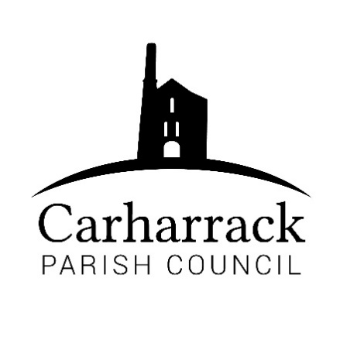 | Carharrack Parish Council
 | Parish Clerk: Joanna Picton
Sparry Farm
Sparry Bottom
Carharrack
TR16 5SH
Tel: 01209 822631

E: clerk@Carharrackparishcouncil.co.uk
W: www.carharrackparishcouncil.co.uk
Parish Council Meeting Minutes – 12th June 2023 OM12/06
7pm at The Mills Hall, Carharrack

- Persons Present/Apologies – All present Cllrs Holland, Aldridge Constable, Garbett, Harry, Payne and Clerk. Apologies CC Donnithorne

- Chair Welcome and acceptance of the standing order and code of conduct- Chair welcomes all to the meeting and accepts the code of conduct and standing orders.

- Declarations of Interest from Members/Dispensations – Mills Trust Cllr Aldridge
To RECEIVE any Declarations of Interest from Members. To RESOLVE to grant any requests for Dispensation in line with the New Councillor Code of Conduct 2022 if appropriate.

- Public Participation – None present

- Cornwall Councillors Report Update on current issues from C.C. Connor Donnithorne, read by Cllr Holland to the parish councillors. Armed forces day 24th June. Brokenshire corner road markings being chased as a priority. Community chest available for grants.

- Parish Council Meeting Minutes for the meetings held on Monday 17th April 2023 and Monday 15th May 2023. Signed by the chair. Matters arising, the bus shelter and 20 is plenty. Councillors discuss the 20 is plenty campaign. All in agreement for the minutes.

- Finance-
- Clerks’ salary, home working allowance plus any reimbursements
- Payments due via direct debit invoice: Website £23.99 + emails £6.60
- Reimbursement to Cllr Aldridge
- Direct debit to Payroll company
- Microsoft package annual payment- £59.99 Total: £2555.20
Proposed by Cllr Aldridge, seconded Cllr Payne. All in favour
- Request from St. Day and Carharrack school for a donation- chair reads the email from the school for the donation for the activities. Councillors discuss the options for the donation. A discussion ensues.
Parish councillors would like to know what the actual costs per child are for the activities. Would they be able to give more notice for the next years activity so it can be budgeted for.
Proposed £300 by Cllr Constable, Seconded by Cllr Aldridge. All in favour to support the school.

- Defibrillators- Training sessions have been offered by the new defibrillator company. End of September could be offered for the training course. Upskilling the community to use the new defibrillator.

- Bus shelter- Panel needed to be replaced, toughened polycarbonate has gone into the space so it cannot be smashed. Proposed by Cllr Aldridge, seconded by Cllr Constable, all in agreement.

- Feedback from SDC CAG Insulation, Energy and Transportation Event – Well received. The parish council attended and were very pleased with the information they received. Parish council would like to pass on their thanks to the group. Quoted as being ‘amazing ladies for putting on the event.’ The group in hoping to expand.

- Good Growth Funding (Shared Prosperity Fund) - Cllr Holland reports. £137million available to groups. Levelling up, and a competitive process. Communities need to be able to access the funds. Chair contacted community officer for the area to put Carharrack on the list for funding. Chair is approaching local community groups to see if they would need help with funding. Chair asks if there’s anyone in the community they can ask if they need some help financially. Cornwall community foundation, offer funding and support to local groups. Councillors discuss the information received. Parish council are keen to look for funding opportunities for the local community.

- Parish Magazine – New magazine has recently gone out for circulation; council are happy with the magazine printing from Control Print. Discussion ensues about quantity of magazines ordered. Proposal to increase the print copy, and magazine costs are increasing. Clerk to call Control Print to ask for a quote for 775 or 800 copies. Cllr Harry suggests to put an advert for the deadline for the magazine onto the noticeboard. Cllr Aldridge would like to feature the allotments harvest festival for the next magazine. Action-Clerk to call advertisers before invoices go out, with cost increases.
- Planning- Application for Non-Material Amendment to PA19/08919 for a replacement dwelling, namely 1) Replacement of external timber cladding with coloured composite cladding. 2) Replacement of stone cladding with mixture of painted render and coloured composite cladding.
Willowford, Little Carharrack, Carharrack, Redruth Cornwall. TR16 5RS.
Councillors discuss the application. No objections from Carharrack Parish council. Action- Clerk to update planning.

- To co-opt a new Councillor- Clerk to readvertise with a new advert.

- Carharrack Summer Fayre – There is going to be a fayre on 22nd July, would the parish councillors like to have a table for the community. Discussion ensues about the fayre. Chair to approach the ICE group for information about having a table.

- Agenda Items – IBC for the allotments.
- AOB- Cllr Aldridge has a couple of issues, 3 people cleaning the bus shelter before the meeting. There was an incident with people taking food from the pantry and have made a huge mess in the bus shelter. 3 people have kindly gone to clean it up. People are afraid to mention names because of comeback. Food pantry need to change access for the community. Social club would like to have a defibrillator fitted, could they come to the meeting to discuss this. They could receive community funding.
Meeting closed by chair at 20.26

